Student video submissions in DMU Replay and Blackboard

- Navigate to Panopto.dmu.ac.uk

- Click the Sign In buttons

- Log in using your usual Blackboard pnumber and password

- Click Browse

- Locate and click the Assignment Folder for the module you are submitting for

- Ensure you are looking at the Assignment Folder

- Click Create followed by Upload media

- Click the grey box and browse for your video. Note: you may also drag and drop here

- The system will upload your video – wait for the green bar to disappear

- Close the smaller inner window

- You will receive an email from DMU Replay – this is your digital receipt. Note: if you do not receive this email within 24 hours please contact ITMS to report a fault

- Copy the View link onto your computer’s clipboard

- Log in to Blackboard and go to the appropriate module shell

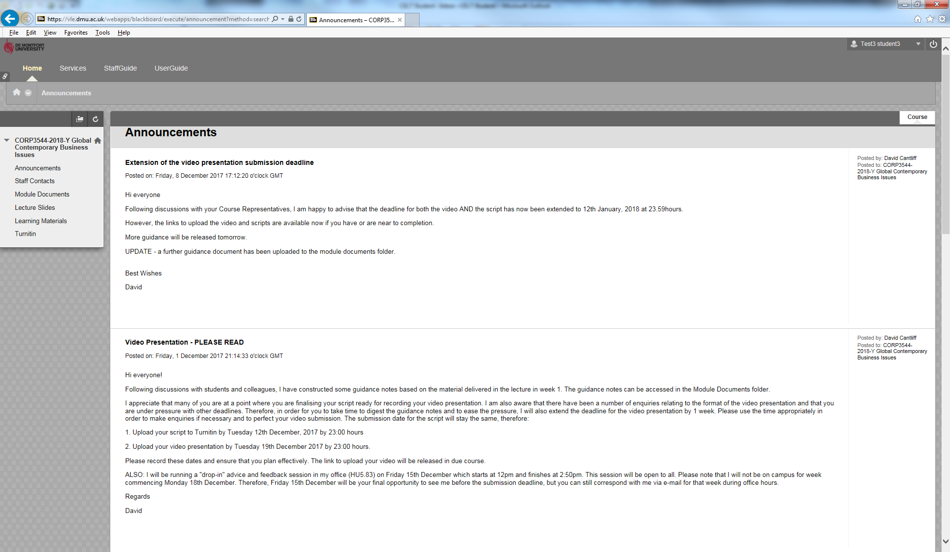

- Locate and click the appropriate Video Presentation submission link

- Paste the View link from the email into the Comments box and click Submit

- Ensure you see the Success message in Blackboard to confirm your submission. Note: if you do not see the Success message contact ITMS to report a fault

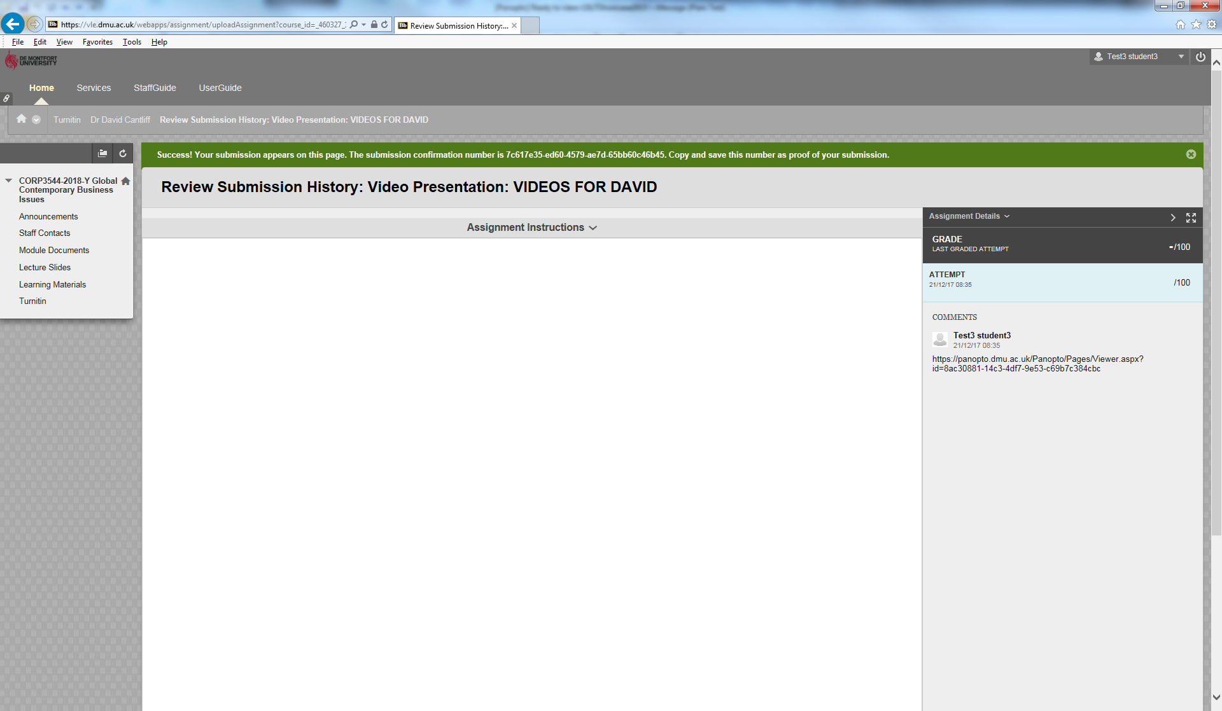

- You have now uploaded and submitted.

