Enabling the DMU Replay Assignment Folder for students to record and upload to
This guide provides information that will help you to facilitate students uploading to the DMU Replay system whilst maintaining a level of privacy by default.
The Assignment Folder function provides a space that students can access when either using the DMU Replay recorder software or when uploading videos that may have been recorded using other software and devices for assessment.
What you will need
- An Internet connected PC – to perform these actions you do not need any specialised software, only an Internet connection and a web browser.

1. Once logged on to the computer, open your preferred web browser and navigate to panopto.dmu.ac.uk
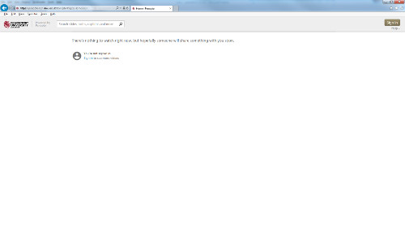
2. Click Sign and use your Blackboard credentials to access DMU Replay
In order to log in here you must be an Instructor on a ‘DMU Replay provisioned’ Blackboard shell. DMU Replay provisioning can be done by Instructors on the Blackboard shell, click here to view the guide
3. Click Browse and select the Folder (Module) for which you want to enable the Assignment Folder
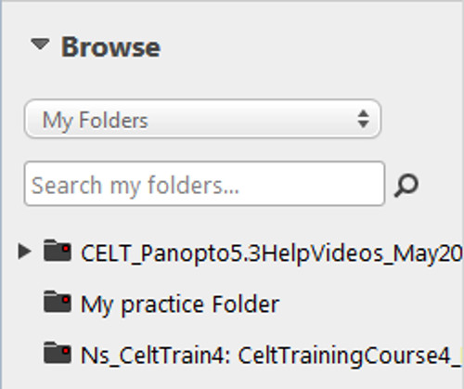
4. Once in the Folder, click the Folder Settings icon
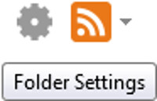
5. Click the Create Assignment Folder link
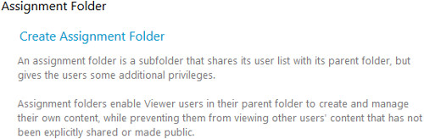
6. A new Folder will appear underneath the Module Folder in the left hand side
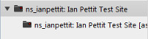
Colleagues and student will now be able to select this Folder when recording but student recordings in the Assignment Folder remain private between the student and the Instructor(s)
If you wish to explore different ways in which DMU Replay may be able to help with innovation please contact your local ELT Project Officer

