DMU Replay – desktop recording QuickGuide

1. Start the computer as normal.
2. Check that the Lync phone (Polycom CX600) is the default recording device by right clicking the volume icon and selecting recording devices
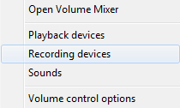
3. Ensuring that the Polycom option is selected – click OK
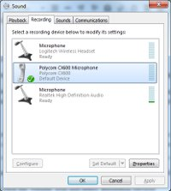
3. Open a web browser and navigate to the software portal here https://software.dmu.ac.uk/jukeboxdrm/showStreamit.do
4. Log in and click the DMU Replay link
If you are planning to use the software whilst offline, please launch the Portable version.
5. The CloudPaging player will open on the PC and DMU Replay will subsequently open
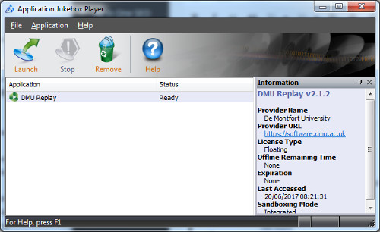
6. Log in with your DMU credentials
If you are logging in to the Portable version for offline recording you MUST check the Remember Me option on the log in screen
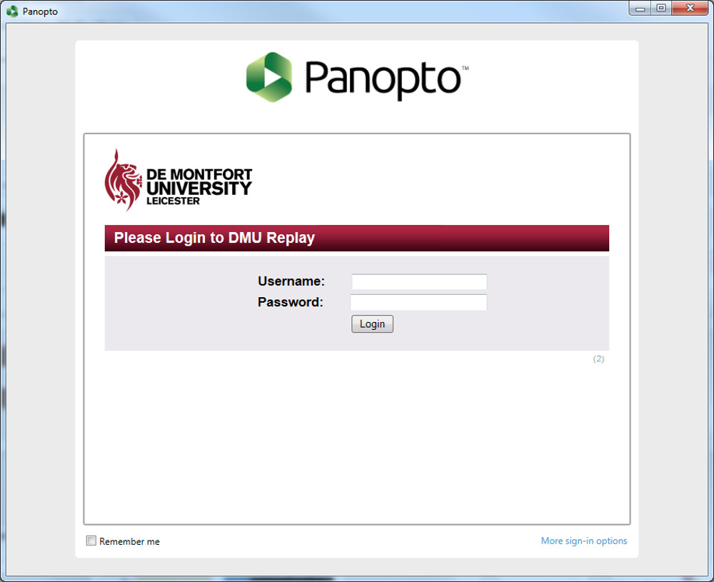
7. The DMU Replay window will open
Unlike in a classroom, there will be no default Audio device selected
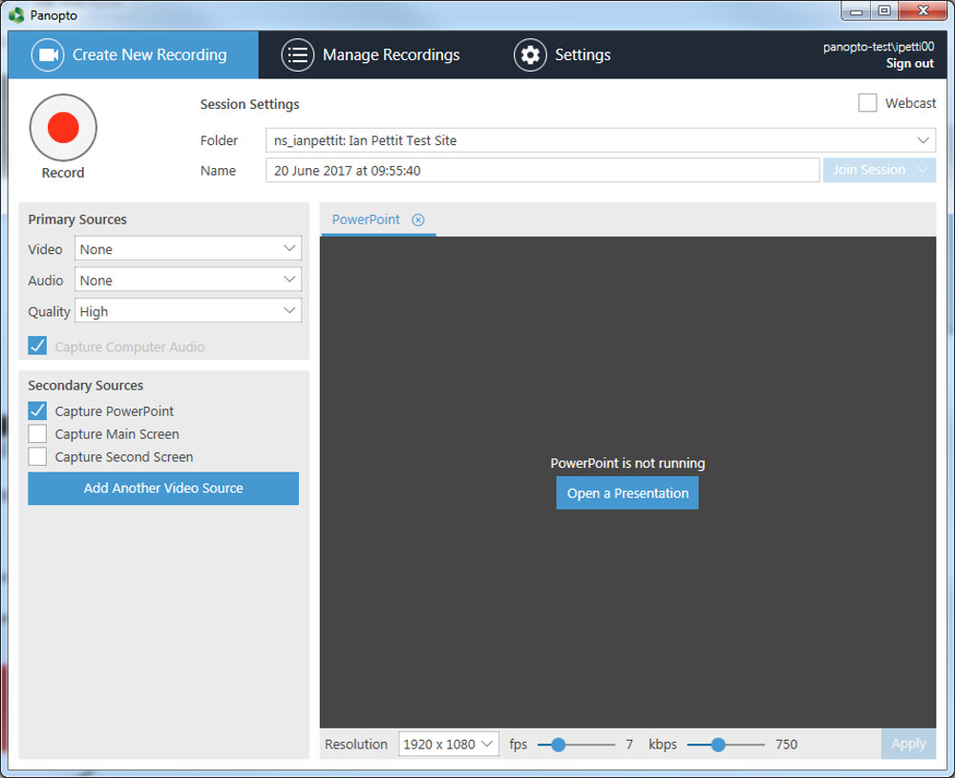
8. Select the sources that you want to record – Video/Audio/Secondary Capture Sources
9. Once happy that you have the desired sources selected, click the ‘Record’ button and proceed with recording the tutorial video
10. Once the tutorial video is finished and you are ready to stop the recording, click the ‘Stop’ button.
11. You will be notified that the recording has completed successfully, click the Upload button
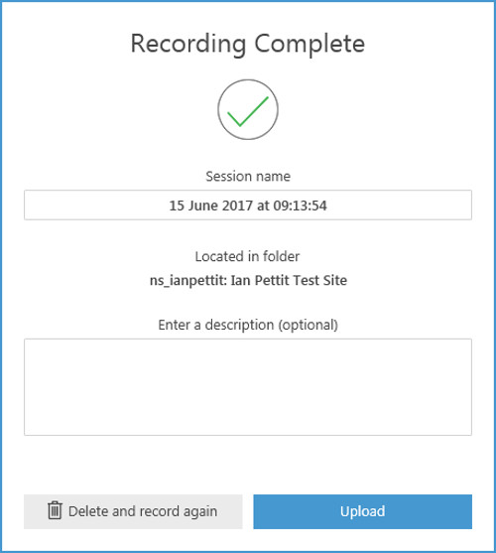
12. DMU Replay will now upload the entire recording
You must wait until the Upload process has finished before logging off of the computer

