DMU Replay – Classroom recording QuickGuide
If you open your PowerPoint slides from either Blackboard or PowerPoint Online (Office 365); please save a copy to the computer desktop prior to following this guide
1. Log on to the classroom computer as normal
2. The DMU Replay software will start automatically
3. Log in with your DMU credentials
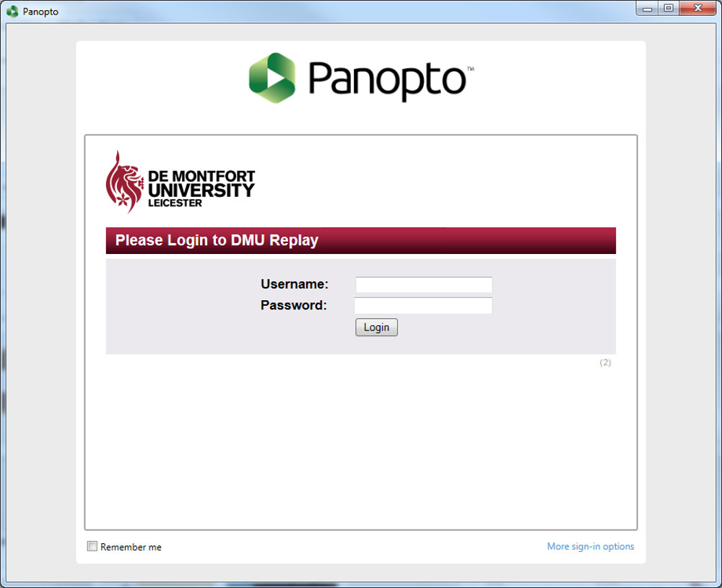
4. The DMU Replay software will be displayed with the default settings
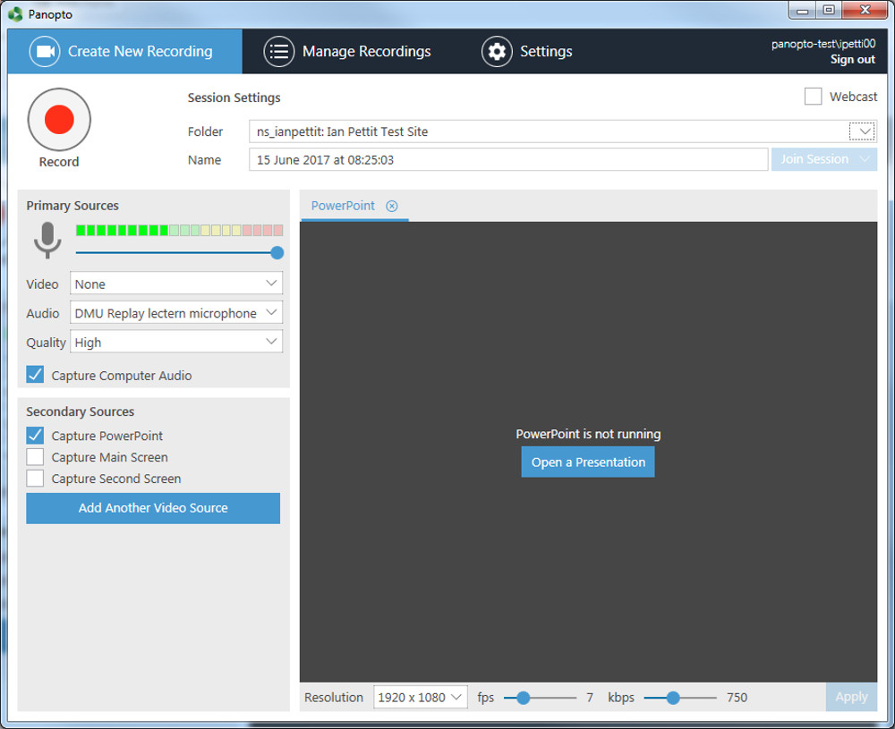
5. Click the arrow button to select the Blackboard shell that the recording will be associated with
6. In the list that appears, click on the desired Blackboard shell
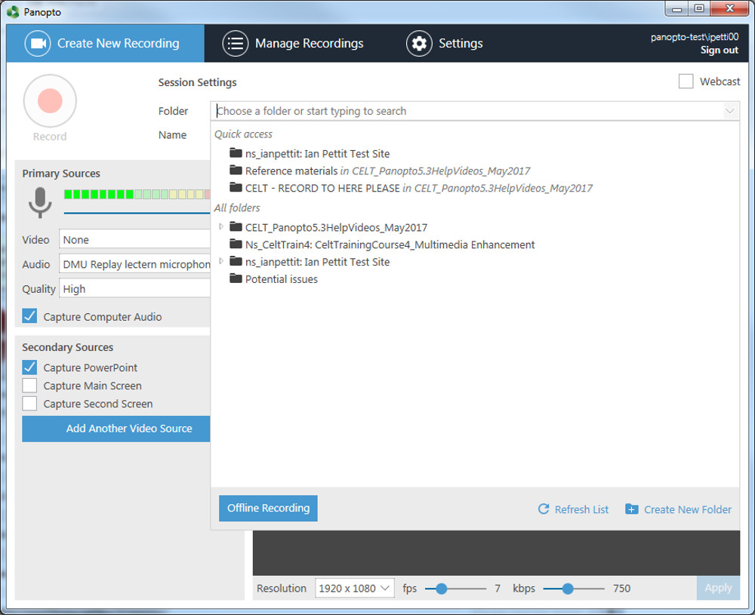
7. If recording video, select the secondary video source from the drop down menu
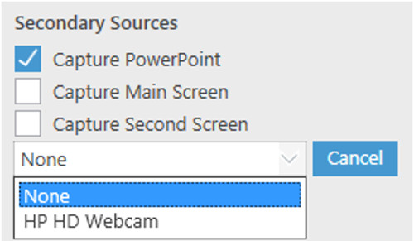
8. If recording the desktop computer screen select the Capture Main Screen option in the Secondary Capture Sources panel
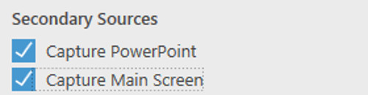
9. Click the Open a Presentation button
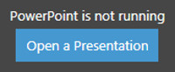
10. Locate your slides and click the Open button
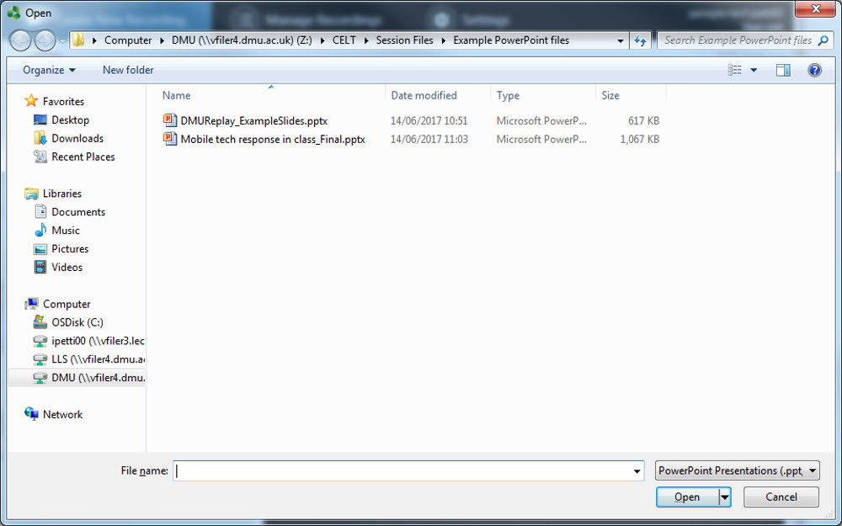
11. You will now see a box asking if you want to begin the recording once PowerPoint is open
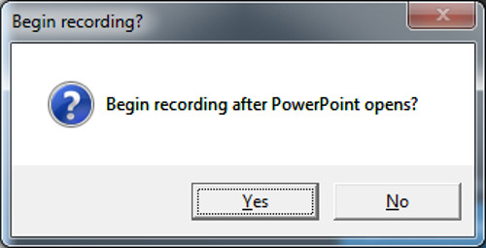
12. Click Yes and the first slide will be displayed – the recording has now started
13. Once the lecture is finished and you are ready to stop the recording, click the Stop button
14. You will be notified that the recording has completed successfully, click the Upload button
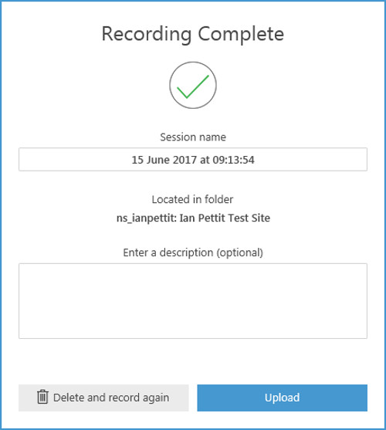
DMU Replay will now upload the last part of the recording and you must wait until the Upload process has finished before logging off of the computer
15. It is now possible to log off and leave the classroom as all of the processing work to make the recording ready to add to Blackboard is completed behind the scenes

