DMU Replay – adding a recording to Blackboard
1. In Blackboard, navigate to the module shell to which the recording was associated
2. Go into the desired content area where you wish the recording link to appear
DMU Replay links should be placed in the Learning Materials content area
3. In the Tools menu select Panopto Video Link
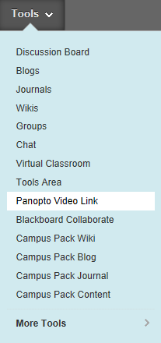
4. Select the ‘Folder’ (this will be the module title) and ‘Lecture’ (this will be the recording) using the drop-down boxes provided; enter a meaningful title and description in the boxes provided (the students will see these) and click ‘Submit’.
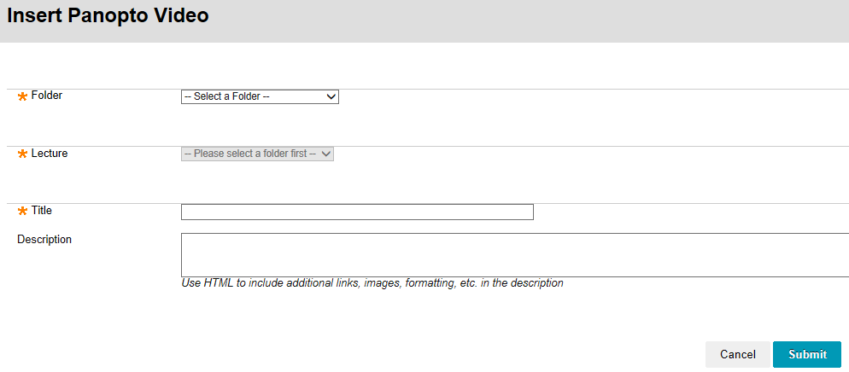
5. A confirmation of the item being created will be displayed – click ‘ok’ to return to the Blackboard content area
6. The content area will now show a new piece of content with the including the title and description as input previously
