Sharing DMU Replay content with individual students or with wider groups

Once a recording has been made and uploaded to Blackboard, the students and colleagues who are enrolled on the relevant shell are given permission to view it by default. However, as we may wish to edit the recording between finishing it and making it available to the students, nothing is automatically published or added to Blackboard. Therefore, when we are ready to share the link to the DMU Replay recording with the audience we need to add a link to the Blackboard shell in order to provide access to it for the students.
There may be scenarios where we may wish to restrict who can view a recording further or maybe share it with a wider audience. This guide firstly talks about adding a link to Blackboard for enabling access to the recording and it then talks about working with permissions in the DMU Replay dashboard.
Working with DMU Replay recordings in Blackboard, working with permissions, editing and managing recordings can be done from almost any internet-connected computer as these areas are accessed via the web browser. You do not need the DMU Replay software to perform these tasks.
What you will need
- An Internet connected computer.

Adding a link to Blackboard
The following steps describe how to add a DMU Replay link to Blackboard. As the default permissions on the recording relate to the permissions of the Blackboard shell, all Instructors on the shell will be able to edit the recording, and all students on the shell will be able to view it.
1. Open Blackboard, log in and navigate to the module shell to which the recording was uploaded.
2. With the Blackboard edit mode on, navigate to the Learning Materials content area and click on ‘Tools>Panopto Video Link’.
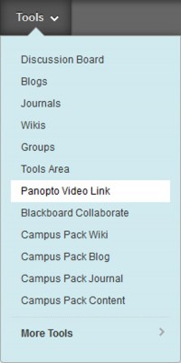
3. Select the Folder and Lecture using the drop-down boxes provided.
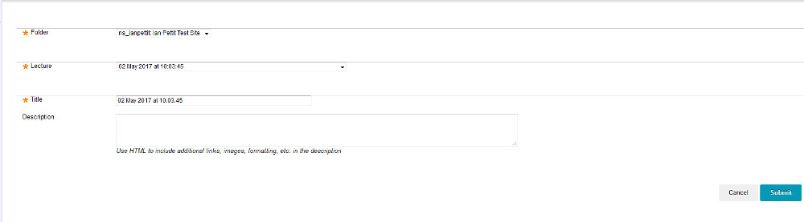
4. Type a meaningful title and description in the boxes provided (the students will see these) and click on Submit.
5. A confirmation of the item being created will be displayed – click Ok to return to the Blackboard content area.
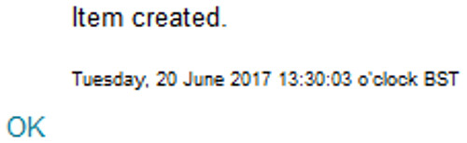
6. The content area will now show a new piece of content with the Panopto logo and the title and description as input previously.
When students click this link, their default web browser should open and after logging in using their Blackboard username the Panopto viewer should be displayed and the recording will start to play.
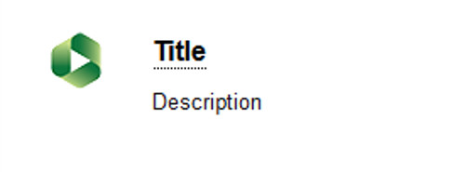
Back to top

Working with permissions
By working with permissions directly in the DMU Replay dashboard we can widen or restrict access to a recording. This is particularly useful when creating student feedback videos as these will generally be viewable by only the student whose work they relate to. It is also possible to set up a ‘placeholder’ with permissions ahead of recording and this is covered in the Managing your recordings guide.
1. To access the DMU Replay dashboard, open your preferred web browser and navigate to panopto.dmu.ac.uk
2. Log in using your Blackboard username and password
3. Once logged in you will see the Home view – this gives you an overview of all of the recordings in all of the folders that you have access to along with items that might be shared with a wider audience
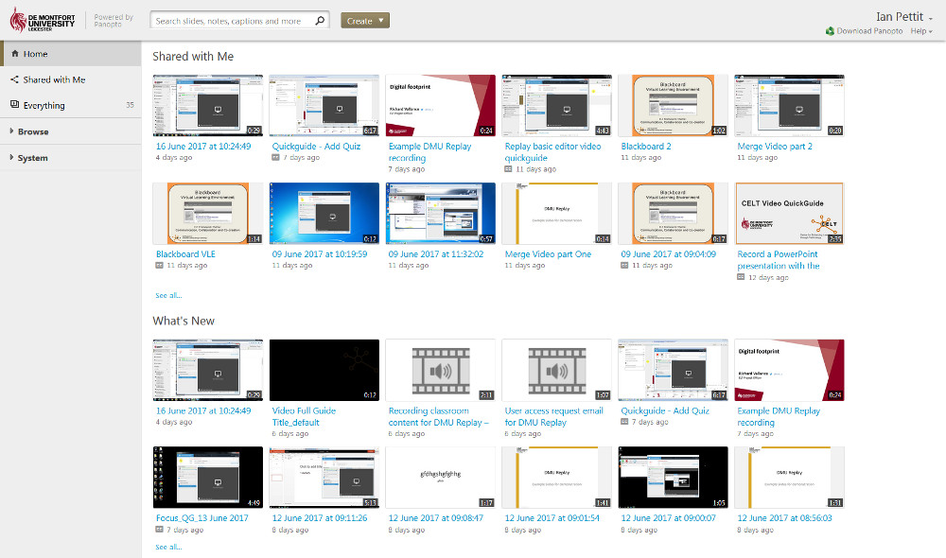
The Home view will appear different for everyone
4. In the left hand side, click Browse to see a list of folders that correspond to the Blackboard shells that you have access to
5. Click on the folder in which the recording you wish to work with resides
6. You will now see a list of recordings that are contained in the selected folder
7. To change the permissions on a recording, hover over the recording and click the ‘Share’ icon.
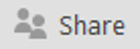
The Share settings will now be displayed for the recording; by default the recording inherits the Blackboard based permissions from the folder and thus the recording is accessible by Instructors and Students on the Blackboard shell
However, this can be changed in order to provide enhanced privacy or widen access to the recording
Back to top

Widening access to a recording
1. To change the access permissions, click the box labelled Specific people.
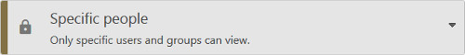
2. Select the appropriate level of access from the list, as described below
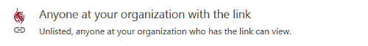 | This setting enables anyone at DMU (staff or student) to view the recording but they need to have been sent the link and they will need to log in to view the recording. Recordings shared in this way do not appear in the Home view and they will not appear in searches.
 | Similarly, this setting requires viewers to log in to view the recording but they do not need the link as the recording will be open to searches (once logged in) and recordings shared in this way will appear in the Home view following log in.
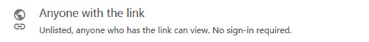 | Anyone with the link removes the requirement for viewers to log in. However, this setting precludes recordings from included in web search results both within DMU Replay and on the wider web (e.g. Bing and Google searches) and recordings will not appear in the Home view.
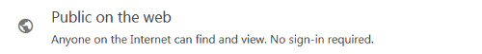 | This setting fully opens up the permissions and enables search engines such as Google and Bing to find the recording. Also when staff, students and visitors navigate to panopto.dmu.ac.uk this recording will be available in the Home view whether logged in or not.
3. Once the appropriate permissions level is selected click on Save changes
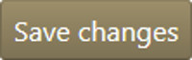
It is possible to share recordings with module cohorts but this practise is not recommended as it becomes problematic as Blackboard shells are rolled over. If you need to make a DMU Replay recording available to a complete other cohort, copy the recording and place the copy in the appropriate module Folder.
Back to top

Restricting access to individuals
1. Follow the steps above to locate the recording and click the Share icon
2. In the Invite people: box type the name, pnumber or staff id of the individual you wish to share with as required
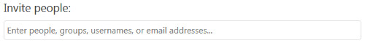
DMU Replay will search for the person as you type
3. Once found click the individual in order to populate the field, deselect Notify people via email and click Save changes
Back to top

Working with permissions we can create a scenario in which we can use multimedia as a feedback mechanism when marking student assignments. There are already examples of colleagues using screen cast software to produce a video of their screen showing the assignment and with spoken feedback and this guide talks about how to create such videos using DMU Replay.
If you wish to explore different ways in which DMU Replay may be able to help with innovation please contact your local ELT Project Officer.

