Recording in a classroom with DMU Replay
What you will need
All timetabled teaching spaces at DMU can support the recording of audio with slides and/or screen without the need to borrow equipment. However, you may wish to record other devices and these can be obtained from AVloans or from your faculty contact. Your local ELT Project Officer will be happy to talk to you about deciding what to record in order to add maximum value to the resource without creating something that might be distracting and unwieldy for the students when watching it back

1. Check that the PC is switched on underneath the lectern
2. Ensure that the red light next to the ‘on/off’ button and the red light next to the PC button on the console are illuminated
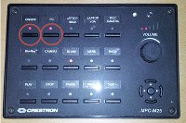
In some lecture theatres you may find that there is a touchscreen rather than buttons on the lectern – ensure that PC is selected
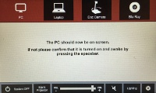
3. If required, turn on the desktop monitor and log in as usual.
The DMU Replay software that will open automatically after approximately 30 seconds. If you inadvertently close this it can opened manually by clicking on the Windows Start Menu and selecting ‘DMU Replay’
4. Log in using your usual Blackboard log in details and the DMU Replay software will open
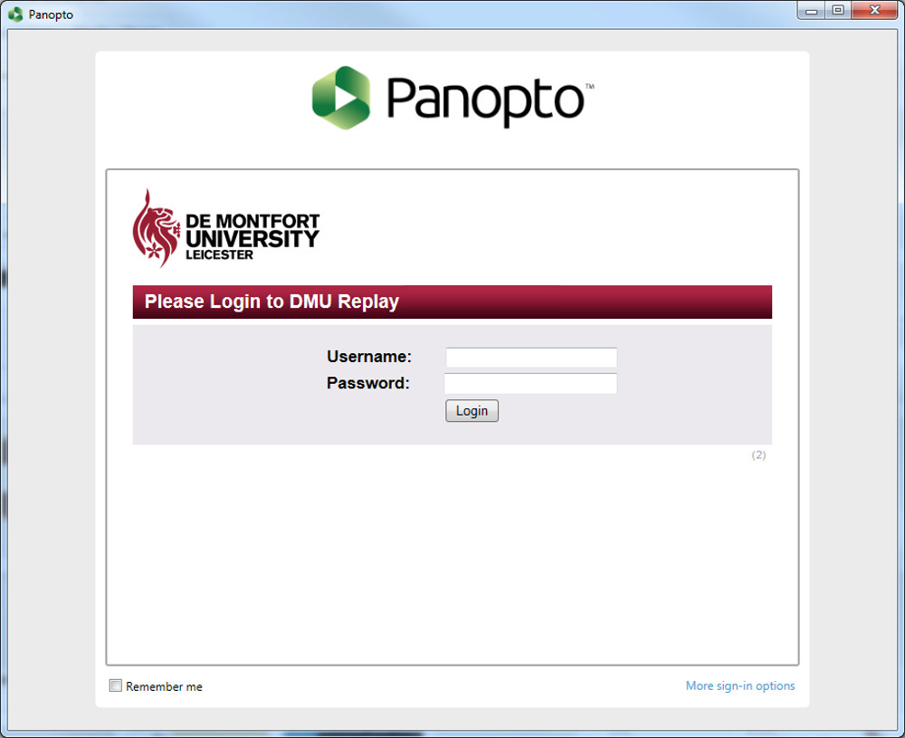
In order to log in here you must be an Instructor on a ‘Panopto provisioned’ Blackboard shell. Without this, an error will be displayed and the DMU Replay software will not open. DMU Replay provisioning can be done by Instructors on the Blackboard shell, click here to view the guide.
5. As DMU Replay opens, the following default settings will be selected:
- Video: None;
- Audio: DMU Replay lectern microphone;
- Quality: High;
- Capture Computer Audio: Yes;
- Secondary Capture Source: Capture PowerPoint;
- Max resolution: 1920 x 1080;
- Bit rate (kbps): 750 and;
- Frame rate 7.
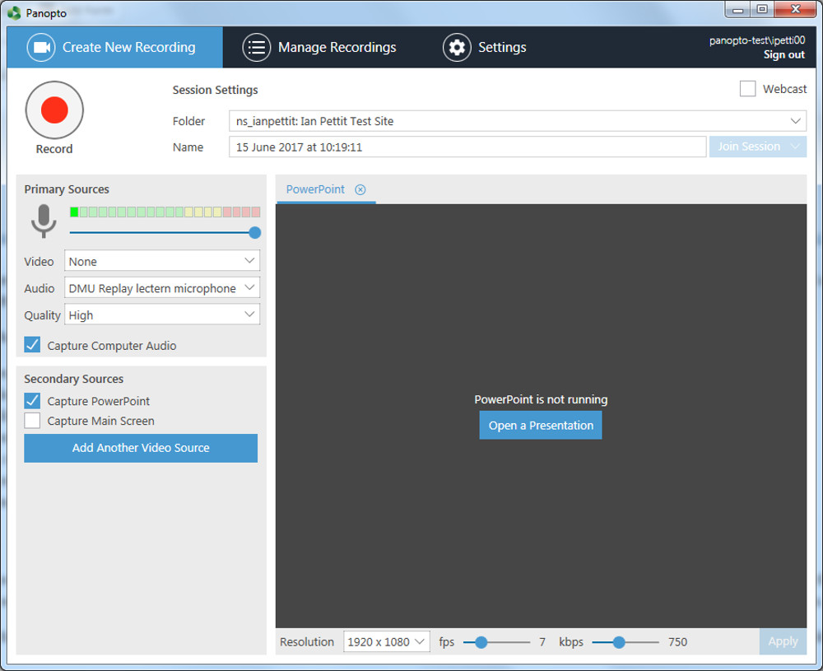
If you are using a wireless USB microphone such as an XTag (available to borrow from AVloans), plug the receiver into USB cable on the lectern and manually select DMU Replay Wireless microphone in the Audio box to make sure that this microphone will be recorded once the lecture starts
6. To select the Blackboard shell (or Panopto folder) that recording will be associated with, click the arrow button next to the Folder name field
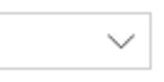
7. In the list that appears, click on the relevant module code
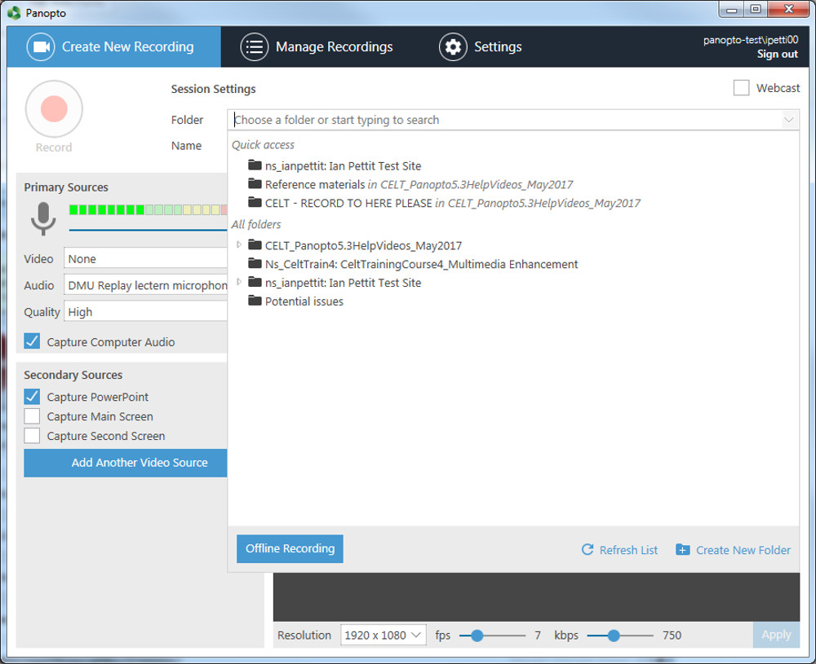
8. Click on the Open a Presentation button
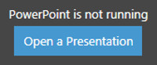
9. Using the file browser, locate your slides and click the Open button
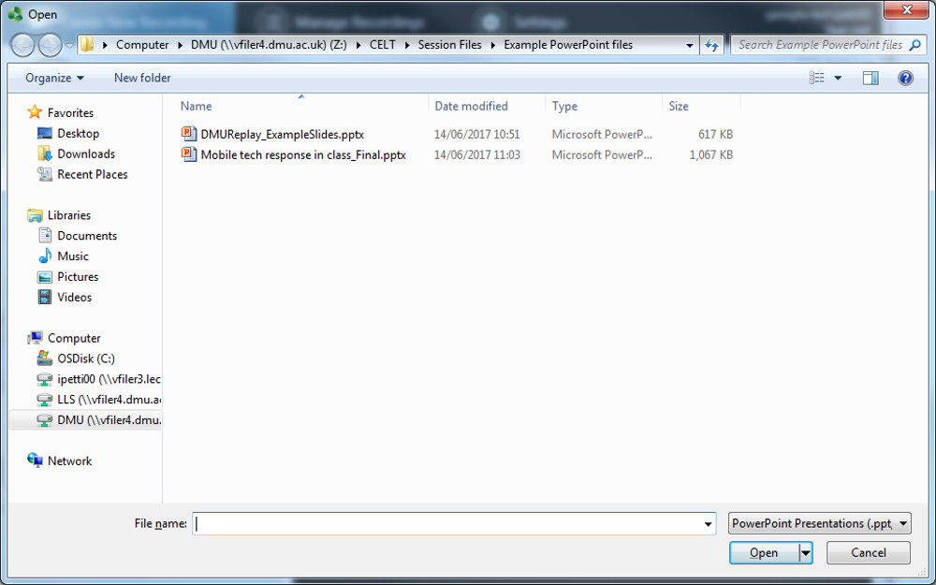
10. You will now see a box asking if you want to begin the recording once PowerPoint is open
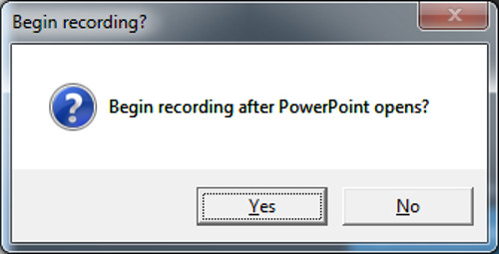
Clicking Yes here will automatically start the DMU Replay software recording and the first slide in the PowerPoint deck will be displayed ready for delivery
If, part way through, you decide to record something else you may move back to DMU Replay and add different streams
For example, you may spontaneously decide to show your students a relevant website during a Q&A session but as only the slides are being recorded this will not appear on the recording. In this example, to include the website in the recording it will be necessary to add the Main Screen to the recording in order to capture the website
To do this, move back to the DMU Replay software whilst recording and check the Capture Main Screen box to the left hand side of the screen
A second tab will appear across the top of the recorder software labelled Main Screen and the screen content from this point on will be captured and included in the resource
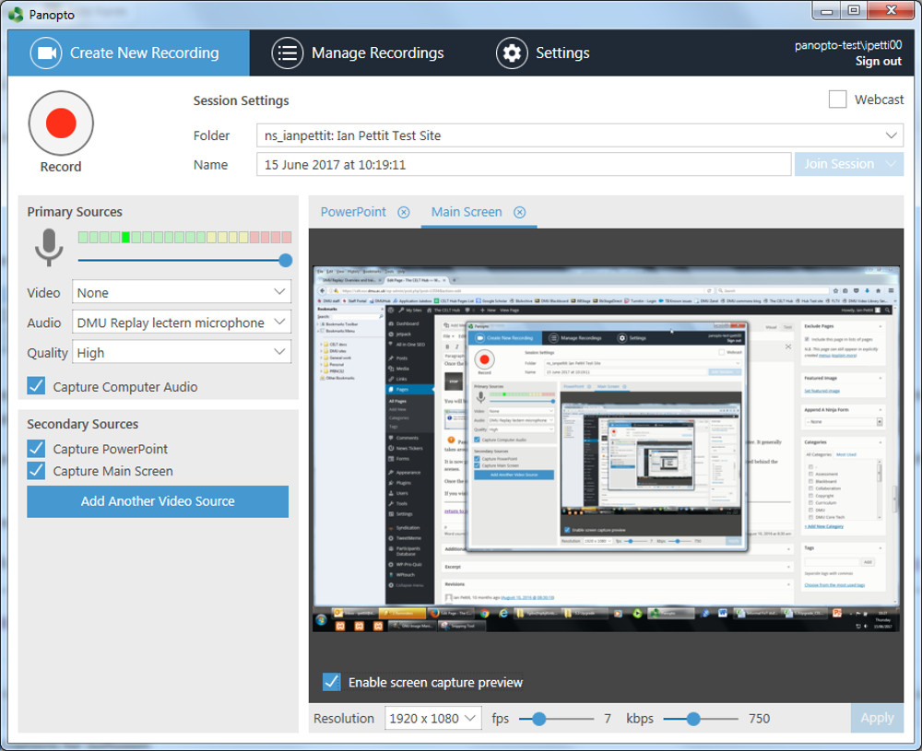
If it is likely that content will be displayed on screen as well as within slides it would be easier to add the primary Screen prior to the recording starting
Once the lecture is finished and you are ready to stop the recording, click the Stop button
You will be notified that the recording has completed successfully, click the Upload button
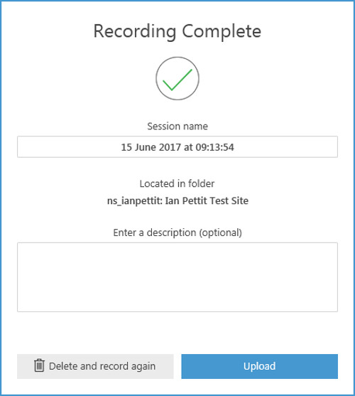
DMU Replay will now upload the remainder of the recording and you must wait until the Upload process has finished before logging off of the computer
It is now possible to log off and leave the classroom as all of the processing work to make the recording ready to add to Blackboard is completed behind the scenes
Once the recording is ready for editing and working with, you will receive an email from DMU Replay
If you wish to explore different ways in which DMU Replay may be able to help with innovation please contact your local ELT Project Officer.

