Recording assessment videos for students using DMU Replay
What you will need
To produce a basic screen cast style video with your spoken feedback you will not need any further equipment. However, you may wish to appear on the feedback video and to achieve this you may need to borrow a High Definition webcam from AVloans or the Faculty contact if you do not have a webcam available
Please contact ITMS if you experience any issues with opening or using DMU Replay

To replicate this practice you will need to have an electronic copy of the student’s submission. Guides relating to using TurnItIn and the Blackboard Assignment Tool can be found at the following links:
- The TurnItIn Staff guide; and
- The Create Assignment guide.
DMU does operate an anonymous marking policy. For clarity, the example below assumes that anonymous marking is in place, students have submitted via TurnItIn, the student submissions have been downloaded using the Print/Download button in the TurnItIn Assignment Inbox view during the period between the Due Date and the Post Date, the submissions are now saved to the computer that will be used when generating the feedback, and feedback videos will be picked up by the students via My Grades
In this example the student has provided their student number in order to provide a unique identifier for audit purposes but as anonymous marking is enabled in TurnItIn the student name is not visible. This use of the student pnumber is supported by the anonymous marking policy
1. Start the computer as normal and check that the Lync phone (Polycom CX600) is the default recording device
To check this on a Windows PC, right-click the ‘volume’ icon and select ‘Recording Devices’. Ensure that ‘Polycom CX600 Microphone’ is set to default
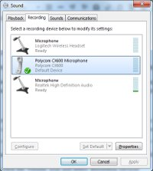
2. Open a web browser and navigate to the software portal here https://software.dmu.ac.uk/jukeboxdrm/showStreamit.do.
3. Log in and click the link to launch DMU Replay
If you are planning to mark electronically but offline, please select the Portable version of DMU Replay
4. The CloudPaging player will open on the PC and DMU Replay will subsequently open
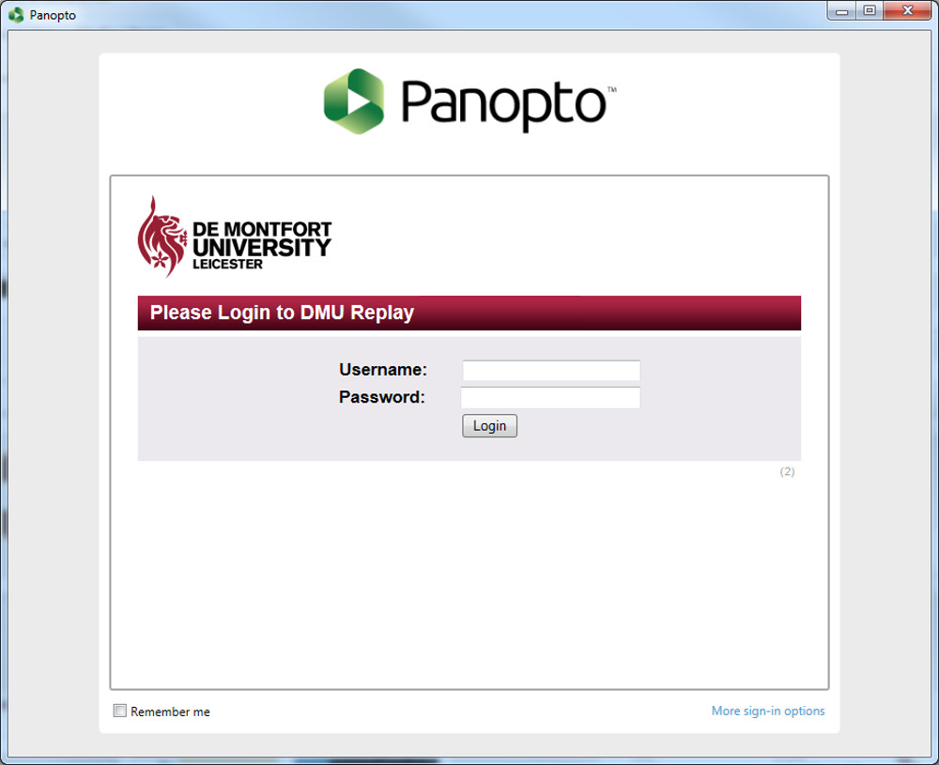
5. Log in using your usual Blackboard log in details
In order to log in here you must be an Instructor on a DMU Replay provisioned Blackboard shell. Without this, an error will be displayed and DMU Replay will not open. Provisioning can be done by Instructors on the Blackboard shell, click here to view the guide

6. As DMU Replay opens, the following default settings will be selected:
- Video: None;
- Audio: None;
- Quality: High;
- Secondary Capture Source: Capture PowerPoint;
- Capture Computer Audio: Yes;
- Max resolution: 1920 x 1080;
- Bit rate (kbps): 750; and
- Frame rate 7.
Depending on what you want to record you can remove the PowerPoint capture as desired
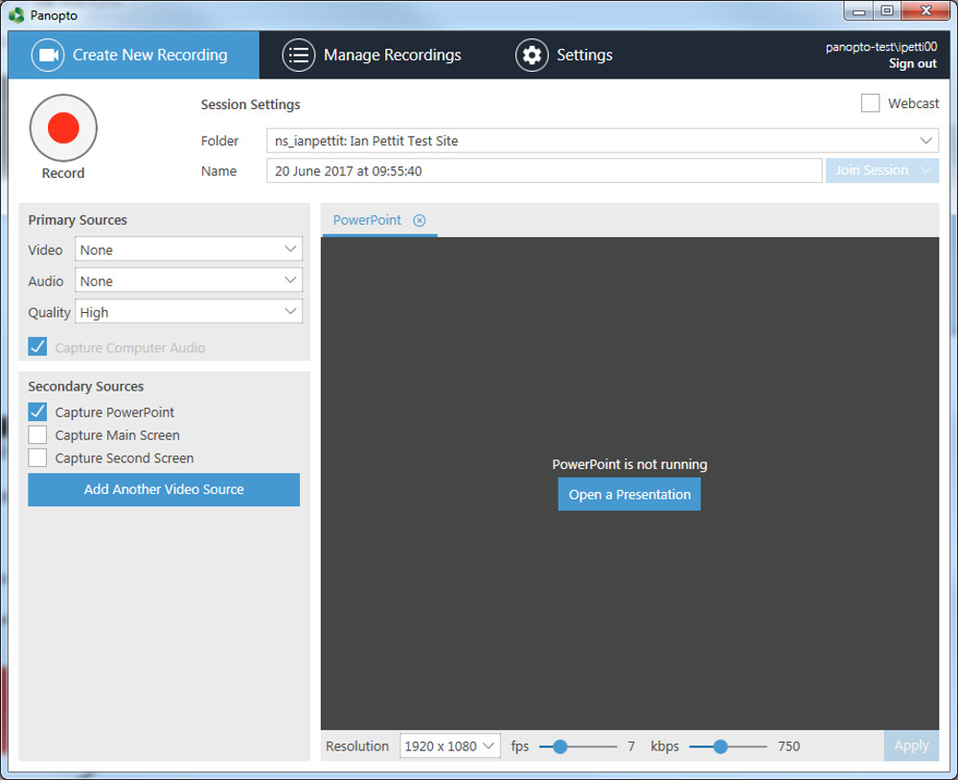
7. Select the sub-Folder that has been created to house this student’s feedback video.
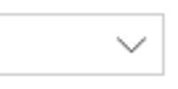
8. There may be other devices plugged into the computer that DMU Replay can record, to add one or more of these click on the Add Another Video Source button and select from the drop down menu as desired
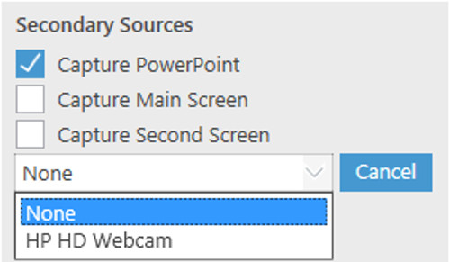
It is important to consider, when recording a video camera, whether we allow DMU Replay to record this as the Primary Source (Video) or as a Secondary Source by adding the video stream using the Add Another Video Source button.
This is important as this will change the view when students watch the recording and when we edit the recorded content. Recording the camera as a Primary Source will associate the audio (sound) with the video and the video feed will be displayed permanently when watching the resource. However recording the camera as a Secondary Source will ensure that the audio remains independent and therefore can be edited independently of the video stream – this enables us to ‘hide’ the video stream when editing should we wish students to focus solely on the screen content at a specific point
For this example, I have opted to record the Primary Screen and my voice only in order to produce the feedback video
I have also turned off the PowerPoint recording as I will not be using any slides in this feedback video

9. Open the assignment that you wish to mark
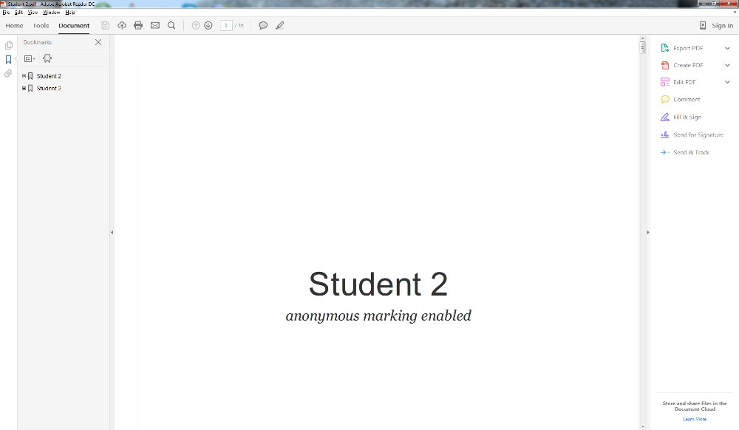
10. Return to DMU Replay and click the Record button
You can now move back to the document and read through the submission, pointing to and highlighting parts of the document using the mouse whilst verbalising the feedback
11. Once the feedback video is finished and you are ready to stop the recording, click the ‘Stop’ button
12. You will be notified that the recording has completed successfully, click the Upload button
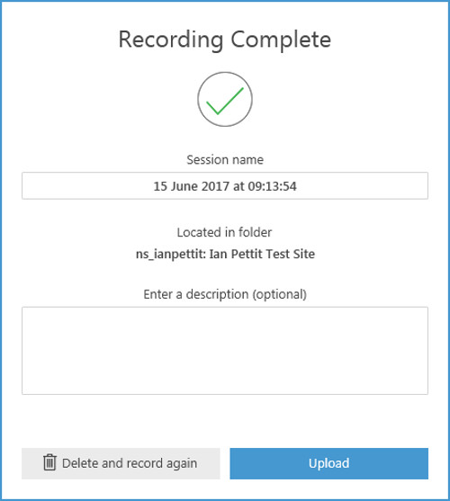
Once the recording is ready for editing and working with, you will receive an email from ‘DMU Replay’
13. Once all of the submissions are marked, log in to Blackboard and locate the Grade Centre column that corresponds with the TurnItIn submission for this component
14. Using the pnumber as the identification, click on the first student in the list in the Grade Centre column and select ‘View Grade Details’
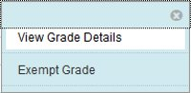
15. Click Manual Override and on the next screen, type the grade into the Override Grade field and paste a link to the student’s feedback video in the Feedback to Learner section
16. Click ‘Save’
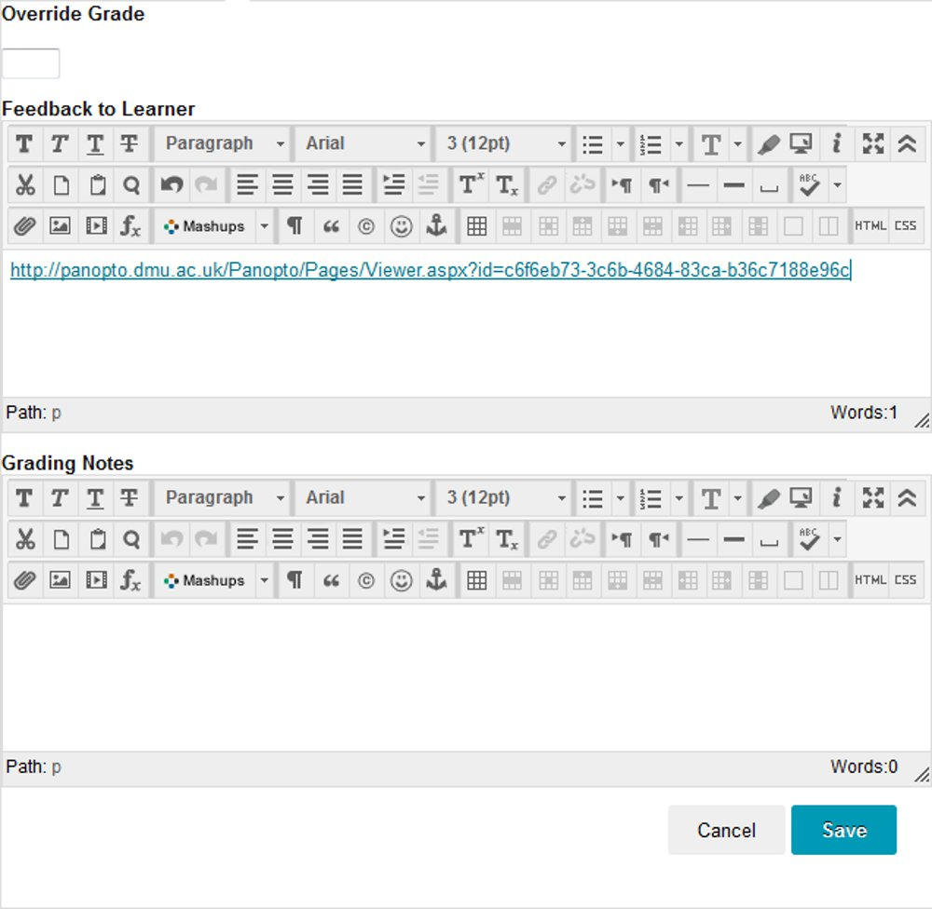
Depending on the Blackboard settings, students will now be able to access the grade and the feedback video via the My Grades link
If you wish to explore different ways in which DMU Replay may be able to help with innovation please contact your local ELT Project Officer.

return to main menu

