Provisioning a Blackboard shell for DMU Replay

This guide talks about the process required to ‘provision’ a Blackboard shell for DMU Replay use. Blackboard shells will generally be provisioned already but if your module has missed the start of term cut off you may need to follow these steps when adding the first DMU Replay link to the shell.
What you will need
- An internet-connected computer.

1. Log in to Blackboard and navigate to the shell that is to be provisioned.
Ensure that the Edit Mode is turned on.
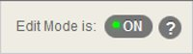
2. Click on the Learning Materials content area in the left hand menu.
3. With the mouse, hover over the ‘Tools’ section and select ‘Panopto Video Link’.
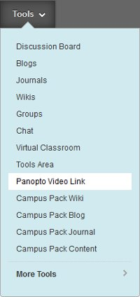
4. Select ‘Add Course to Panopto’.
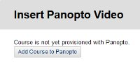
5. Click the second ‘Add Course to Panopto’ button.
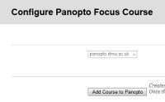
You will now see a report stating that the course was successfully provisioned along with a list of the Instructors and Students who now have access to recordings that might be associated with the Blackboard shell.
6. Click on the ‘OK’ button.
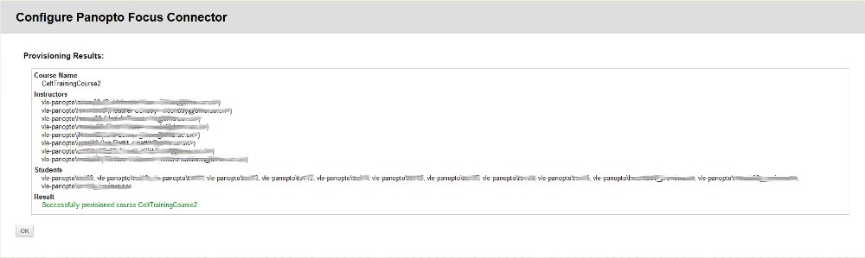
The Blackboard shell is now provisioned. On the next screen you will be given the opportunity to add a Panopto video link but typically there will be no videos to add at this stage as you have provisioned the Blackboard shell in advance of making any recordings.
If you wish to explore different ways in which DMU Replay may be able to help with innovation please contact your local ELT Project Officer.

