DMU Replay – provisioning a Blackboard shell quickguide
Modules are automatically provisioned to accept DMU Replay recordings. However, in some instances a module may not auto-provision and will not appear in the list of available module folders when using the DMU Replay recording software. If it is not available please follow the guide below to provision it.
1. Log in to Blackboard and navigate to the shell that is to be provisioned.
2. Ensure that the Edit Mode is turned on.
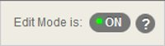
3. Click on the Learning Materials content area in the main navigation menu.
4. From the Tools button select Panopto Video Link.
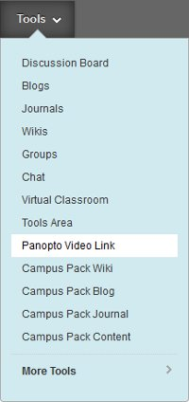
5. Select ‘Add Course to Panopto’.
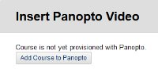
If Add Course to Panopto does not appear – you will need to follow a different method for provisioning the module
6. Click the second ‘Add Course to Panopto’ button.
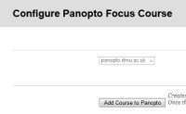
7. You will now see a successful provision report. Click the ‘OK’ button.
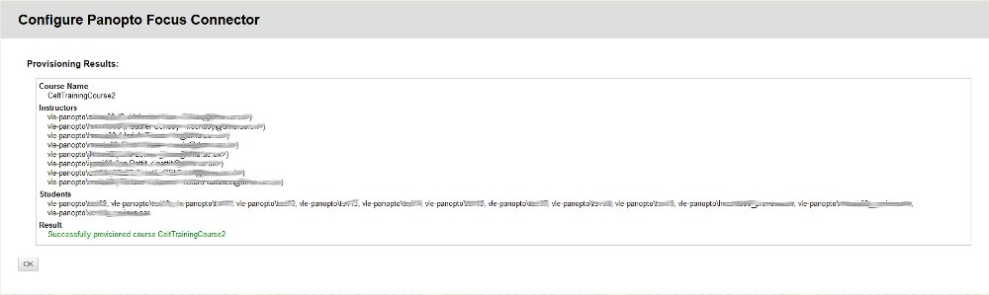

The Blackboard shell is now provisioned. On the next screen you will be given the opportunity to add a Panopto video link but typically there will be no videos to add at this stage as you have provisioned the Blackboard shell in advance of making any recordings.

