Recording at your desk to create bite-sized learning resources using DMU Replay
As equipment varies, it may be necessary to talk to your local ELT Project Officer regarding the specifics of your environment. This guide has been produced using a DMU issued desktop PC. The microphone in use is the Lync telephone (Polycom CX600) that DMU staff members have access to.
To see an example of the type of resources that can be created in this way, watch the Editing recordings and Managing your recordings summary videos that support the use of DMU Replay at DMU.
What you will need
Depending on what you wish to record you may not need any extra equipment. However, if you wish to record a web cam video, and there is not one on your desktop PC you will need to borrow a High Definition webcam from AVloans.
Please contact ITMS if you experience any issues with opening or using the DMU Replay Recorder software.
1. Start the computer as normal and check that the Lync phone (Polycom CX600) is the default recording device. To check this on a Windows PC, right-click the 'volume' icon (at bottom right of the computer screen)
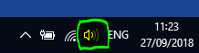
Select Recording Devices
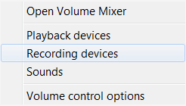
and select the ‘Recording’ tab. Ensure that 'Polycom CX600 Microphone' is set to default.
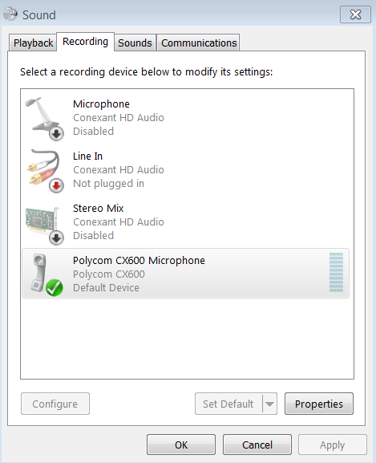
2. Open a web browser and navigate to the software portal:
https://software.dmu.ac.uk
3. Log in and click the launch button next to DMU Replay.
The Application Jukebox player will open on the PC.
4. Click the Launch icon
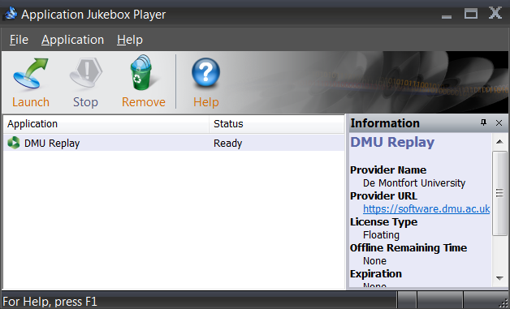
5. Log in with your DMU credentials
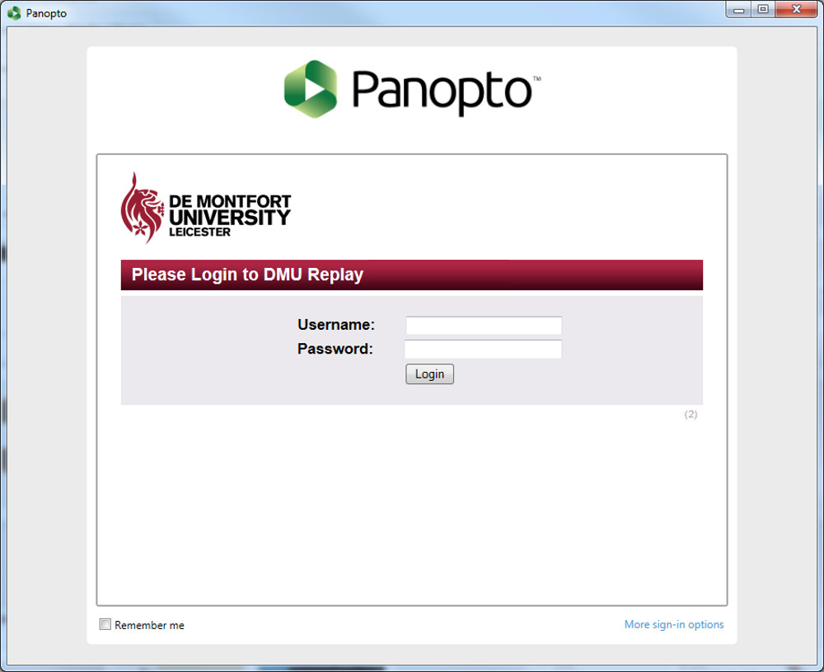
The recording panel will appear
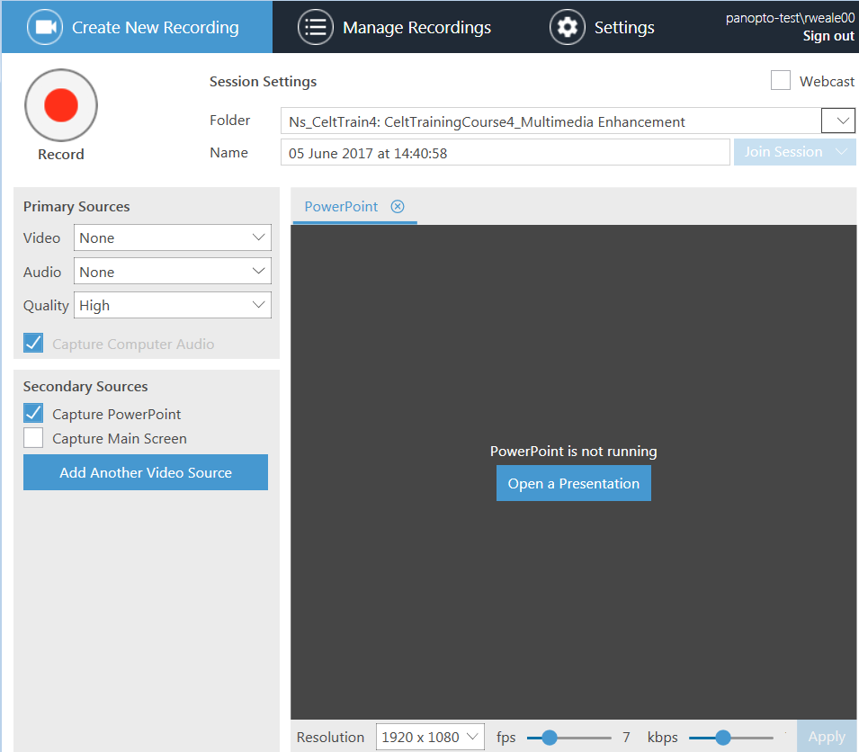
6. Select the Blackboard shell that you want the recording to be associated with by clicking the little arrow to the right of the Folder option at the top of the recorder panel, and choosing the module from the menu that appears.|
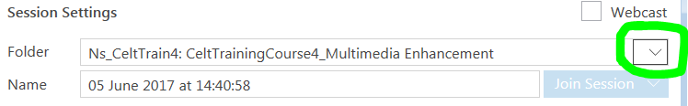
7. Use the Audio option in the Primary Sources panel to select the microphone that you want to record with. In this example the Polycom (Lync) telephone is being selected.
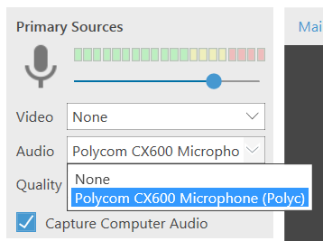
8. In the Secondary Sources window, select any other sources that you want to record.
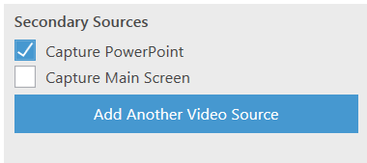
Other video sources (such as an external web cam – if one is plugged in) can be added using the Add Another Video Source button
It is important to consider, when recording a video camera, whether we allow Panopto to record this as the Primary Source (Video) or as a Secondary Source.
This is important as this will change the way that Panopto behaves when students view the recording and when we edit the recorded content. Recording the camera as a Primary Source will associate the audio (sound) with the video and the video will be displayed permanently when watching the resource. However, recording the camera as a Secondary Source will ensure that the audio remains independent and therefore can be edited independently of the video - this enables us to 'hide' the video when editing should we wish students to focus solely on the screen content at a specific point.
9. If you have chosen to record a PowerPoint presentation, you can open, automatically launch and begin recording the presentation by clicking the Open a Presentation button.
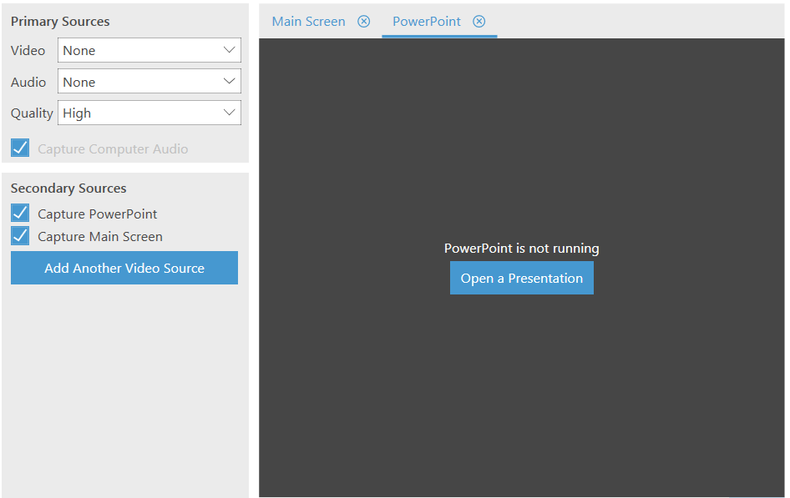
If you are not recording PowerPoint, click the Record button to start recording.
Click the pause button to pause the recording and the resume button to resume a recording
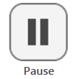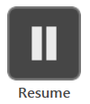
10. Click the Stop button to stop the recording
You will be notified that the recording has completed successfully and the upload panel will appear.
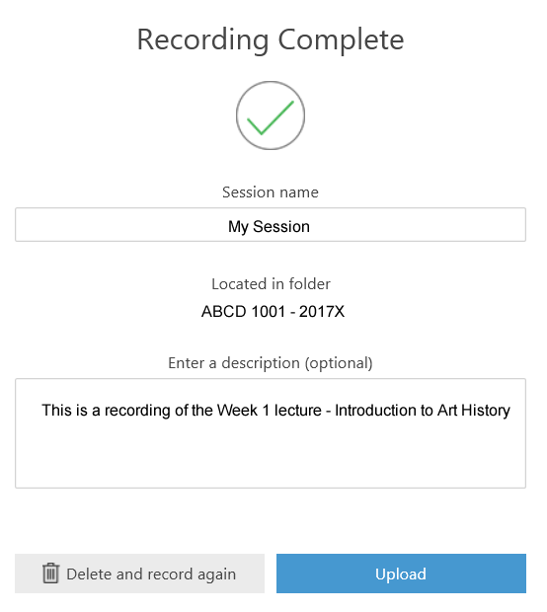
You can change the Session name, and add a description for this recording.
11. To upload the recording to the DMU Replay Server click the Upload button. You can discard the recording by clicking the Delete and record again button – if you do this you will not be able to retrieve the recording.
Once the recording has been uploaded and is ready for you to access, you will receive an email from 'DMU Replay'.
A link to the recording can then be made in your Blackboard module as usual.
If you wish to explore different ways in which DMU Replay may be able to help with innovation please contact your local ELT Project Officer.

