Hiding grades from students using the Grade Centre

Note: Students may be able to view marks via Blackboard apps (Bb lite and Bb student) even if the ‘My Grades’ option is hidden, unless tutors hide the appropriate column(s) in grade centre until marking is complete.

To control the visibility of marks, tutors should hide the relevant GradeCentre column when setting up a Turnitin or Blackboard Assignment link, or any assignment in Blackboard that generates a GradeCentre column (this includes assessed blogs, wikis, Journals and Group work).

Then when you are ready to release marks to all students, ensure that the relevant column is now visible by using the same step: the column header will have a red line on it when marks are hidden from students.
Grades can be selectively hidden from students via the GradeCentre. Also, Blackboard treats grades and feedback in TESTS as two separate items; therefore hiding the feedback in the test options is not enough to prevent students receiving their grade upon completion of the test.

- To hide grades; click on the grey button at the top of the column and select Hide from Students (on/off)

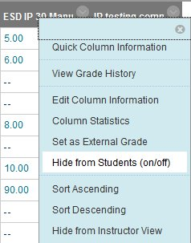
IMPORTANT NOTE: If there is a Total column in your GradeCentre, you MUST hide this from students also as they will be able to see a running total of their marks even from columns that you have hidden.
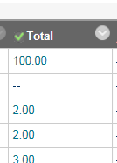

To hide the Total column:

1. In the full GradeCentre, click on the grey button at the top of the Total column and select Edit Column Information
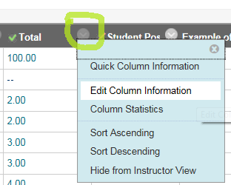

2. Scroll down to the bottom of the page and set Show this Column to Students to No
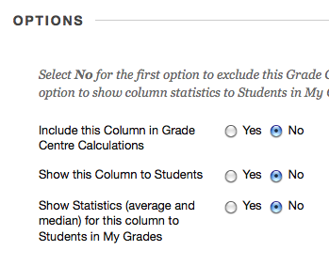
3. Click the Submit button

Tell me more about the Grade Centre

