Delegated Grading in Blackboard Assignments
The Delegated Grading tool in Blackboard enables staff to assign student assignment submissions for marking electronically to colleagues on the Blackboard module.
This functionality is available primarily when using the Assignment Submission tool and can be set up as the Assignment Submission link is created.
Delegated Grading enables two or more staff members to provisionally grade and comment on assignment submissions with one staff member being able to ‘reconcile’ the final grade. The final grade is the only grade that students see in My Grades but students see all comments that may have been made by the delegated grader(s).
Before using the Delegated Grading tool it is important to note that the staff member’s role on the Blackboard shell drives the options that are available when delegating submissions to mark.
Generally, staff at DMU will be enrolled on the Blackboard shell with the Instructor role. In relation to Delegated Grading, this means that staff will be able to see each other’s comments and provisional grade; as well as being able to reconcile the final grade for release to the students.
However, by changing the staff member’s role on the Blackboard shell, scenarios in which those who are provisionally marking cannot see each other’s provisional grade and feedback can be achieved along with restricting the ability to reconcile grades to specific staff members.
The role that would be used to achieve this effect is the Teaching Assistant role. Further help regarding roles in Blackboard and how to change this can be found here:
- Link to the Blackboard roles information page
- Link to How To Change a User role
Note: Where the staff role is changed to that of Teaching Assistant for the marking period, this will restrict the staff member's ability to perform other tasks within the Blackboard shell until the role is reverted to that of Instructor.
In all delegated grading scenarios there is a workflow which comprises of the following steps:
- Identify colleague's Blackboard role and amend if/as necessary
- The Assignment Submission link is set up
- Colleagues are identified as being able to provisionally mark
- Students submit
- Two or more staff members provisionally mark the submission(s)
- One staff member reconciles the provisional marks and the final mark is released to the student in the My Grades view
Using the different roles that are available in Blackboard, the Instructor can cover the following three example scenarios:
- Allocating work to a colleague to grade where both are able to see each others comments and input; both markers are Instructors and are able to reconcile the final grade and release this to the student
- Allocating work to a colleague to grade whilst ensuring that the delegated marker is unable to see the Instructor's comments and input. The Instructor will be able to see the delegated markers provisional grade and only the Instructor can reconcile the final grade and release this to the student. This achieved by changing the Delegated Grader's role to Teaching Assistant
- Double blind marking where neither party are able to see each others comments and input during grading. This involves changing all/both markers role to Teaching Assistant and reverting to Instructor for reconciling
Scenario one – both graders are Instructors and can see each other's input and release the grade to the student
In this scenario both staff members will already be enrolled on the Blackboard shell with Instructor status and therefore no change to either staff member's role on the Blackboard shell is required
To create the Assignment Submission link, navigate to the desired content area; hover over Assessments and click on Assignment
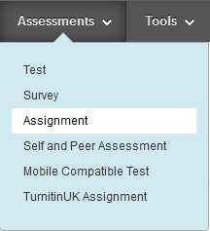
Enter a name, description, due date and points value as normal. Click on Grading Options
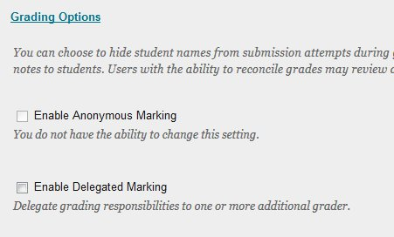
Place a tick in Enable Delegated Marking and the view will change
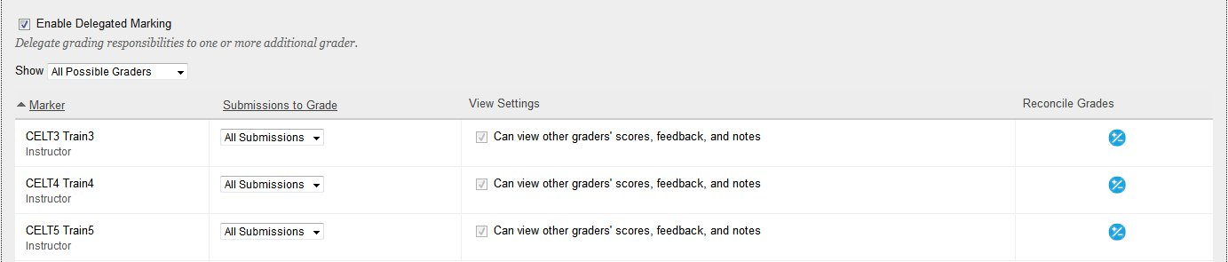
The Marker column displays all of the staff members to whom submissions can be delegated to for grading.
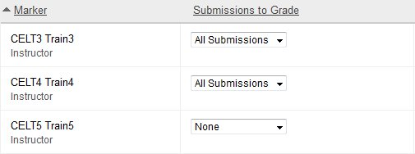
By default, the Submissions to Grade column displays All Submissions for all staff who are able to perform the role of delegated grader.
By clicking the drop-down arrow the following options become available:
- None – this allocates no submissions for the staff member to mark and this staff member will not be included in the scenario
- All Submissions – the staff member will be able to provisionally mark all submissions made to this Assignment Submission link
- Random Set – Blackboard will ask for a numerical value and once entered a random set of of submissions not exceeding the specified numerical value will be allocated to the staff member for delegated grading
- Groups – where the groups function is being used, selecting Groups here will offer the Instructor the option to allocate submissions for delegated grading by group
In this example, it is assumed that there is a small cohort of students and one of the staff members will be set to All Submissions whilst the other staff members will be set to None. The resultant set up is:
- All three accounts shown are Instructors on the shell but only Train3 and Train4 will be allocated work to grade. However, other Instructors on the shell could override this by accessing submissions direct in the Grade Centre and marking them.
Note: It is recommended that when using Delegated Grading in this way that all Instructors on the Blackboard shell are made aware of this practice and advised not to access submissions direct in the Grade Centre
The View Settings column enables the Instructor to decide whether the delegated grader(s) can see the Instructor's comments and provisional grade. In this scenario, this option greyed out and cannot be changed. This is because the delegated grader is also an Instructor on the Blackboard shell. Scenarios two and three talk in more detail about this function and how it can be used to achieve a blind marking set up but here it cannot be changed
As with the View Settings column, the Reconcile Grades column cannot be changed in this scenario due to the delegated grader being and Instructor on the Blackboard shell. This option will also become available later when roles are changed as part of scenarios two and three
With the Delegated Grading options set, click the Submit button
Once the students have submitted, navigate to Control Panel>Grade Centre>Needs Marking
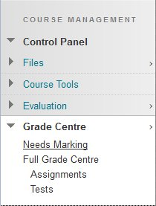
In the list, select the item to be provisionally marked by clicking the link. This list appears in reverse chronological order
Using the grading tools, grade the submission as normal and click Submit
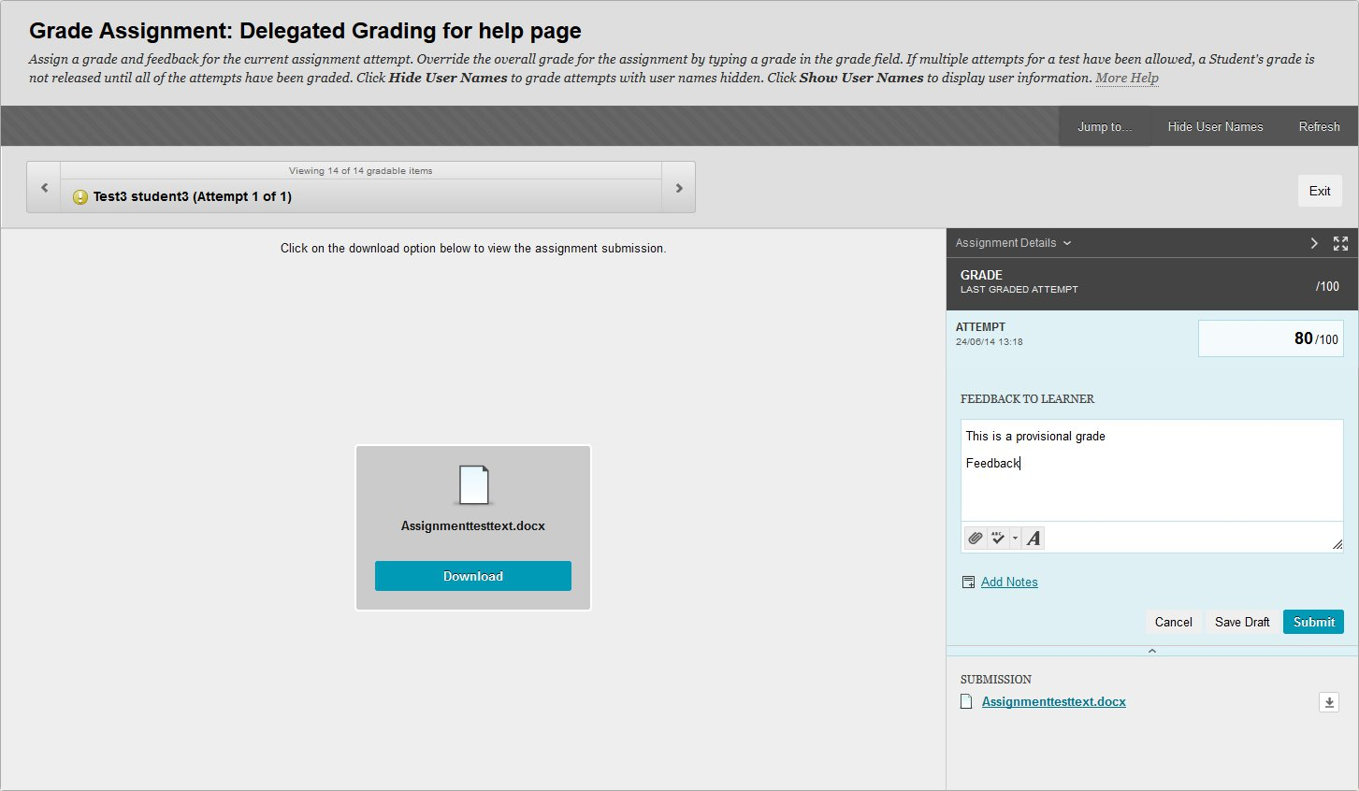
Note: Both graders should perform the steps above to ensure that there are two provisional grades and sets of comments for each submission
At any stage, as both of the graders are Instructors on the Blackboard shell, the graders can enter the Grade Centre and see each other's comments and provisional grades during the marking period
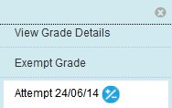
When in the Grade Centre, select the down arrow next to any of the attempts that have been provisionally marked and select Attempt xxx

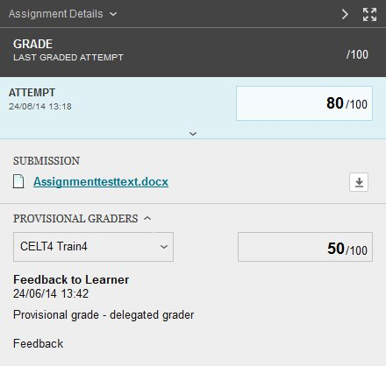
The attempt will open and all feedback and provisional grades are visible.
Note: In this scenario both graders are able to access this view and see each other's provisional grade and feedback as they are both Instructors on the Blackboard shell

Note: The remaining steps are to be completed by the Instructor who is responsible for reconciling and releasing the grade to the student

Navigate to Control Panel>Grade Centre>Full Grade Centre
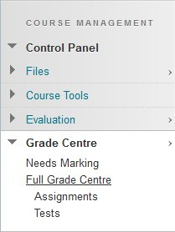
Attempts that require grades to be reconciled will be marked with the Reconcile Grades icon
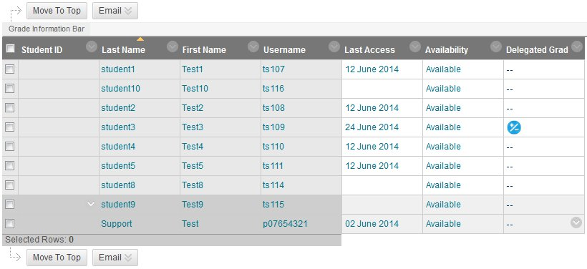
Click on the down arrow next to the attempt and select View Grade Details
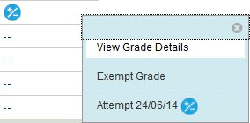
Click on Reconcile Grade
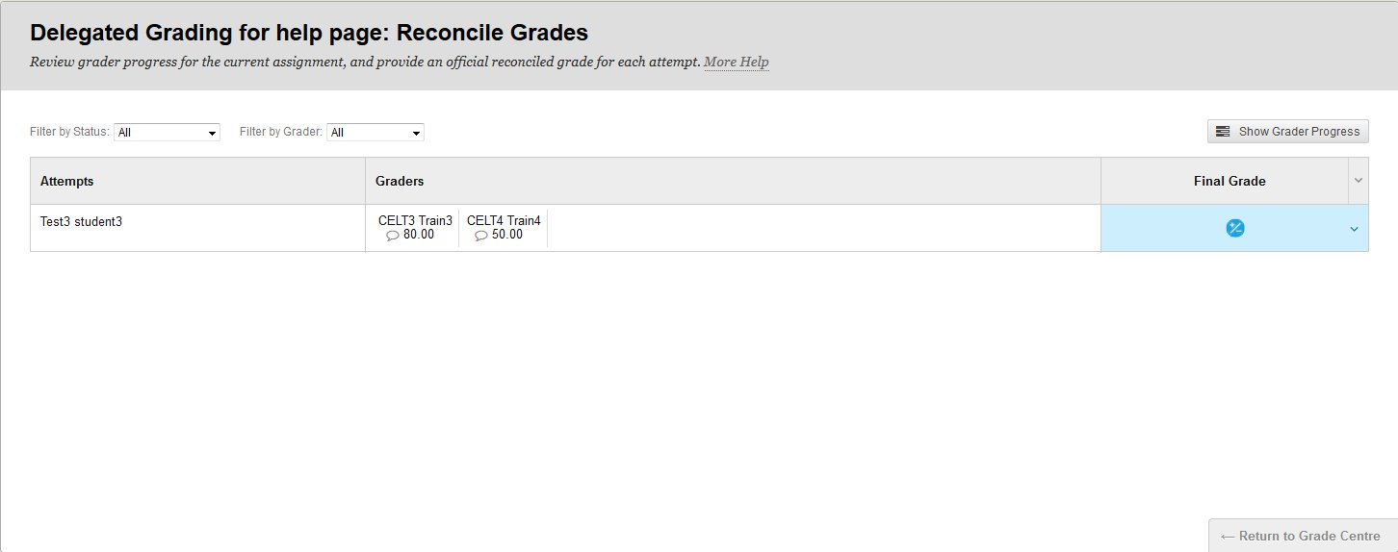
The Reconcile Grade view enables the Instructor who is responsible for reconciling grades to determine the Final Grade.
Click on the Reconcile Grade icon in the Final Grade column and select one of the options or type a value in the space provided
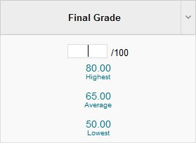
The Final Grade along with the feedback generated by both markers will be available for students in the My Grades view.
The students will not be able to see the provisional grades
Note: The Reconcile Grade view can also be used before all provisional grades are submitted to monitor progress of the delegated grader(s).
Click on the Show Grader Progress button to view a representation of progress at any time during the marking period
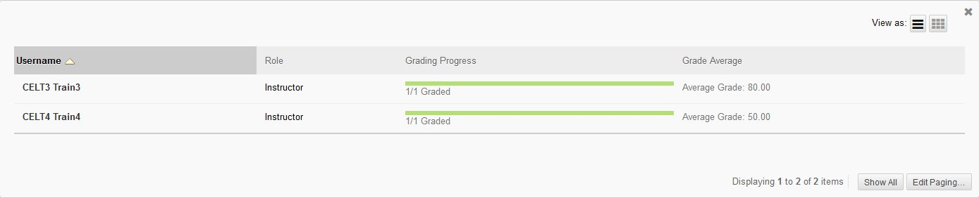
Back to top
Scenario two – one grader is the Instructor and the other's role is changed to Teaching Assistant to ensure only the Instructor can see provisional grades, reconcile and release Final Grades to the students
In this scenario it is necessary for the Instructor to change the delegated grader's role in Blackboard to that of Teaching Assistant. This will ensure that when setting up the Assignment Submission link the options in the
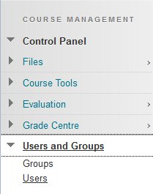
Submissions to Grade and View Settings columns will become active.
Navigate to Control Panel>Users and Groups>Users
Locate the staff member in the user list and click the down arrow then Change User's Role in Course
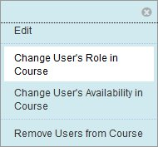
Ensure the radio button next to Teaching Assistant is selected and click Submit

Note: Whilst the staff member's role is that of Teaching Assistant, other Blackboard functions will be restricted – for a complete list of functions that a Teaching Assistant has access to in Blackboard please follow this link to the course roles in Blackboard page
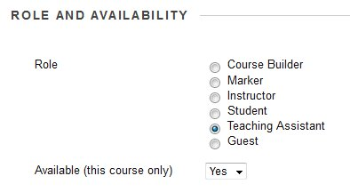
The scenario is now the same as that described in scenario one with the exception that the Instructor has access to the Can view other graders' scores, feedback and notes setting when identifying this staff member as a delegated grader.
- With this setting checked, the staff member with the Teaching Assistant role (the delegated grader) will be able to see the provisional grade and notes that the Instructor may have added whilst provisionally marking
- With the setting unchecked, the delegated grader will not be able to see any provisional grading activity that the Instructor may have completed
Note: In this scenario the Teaching Assistant cannot reconcile and/or release grades to the students at all – only the Instructor is able to carry out these functions and the Instructor can, at any time, see any comments or provisional grading activity that the delegated grader may have carried out
Once all of the submissions have been provisionally graded by the delegated grader and the Instructor the Instructor should follow the steps as described in scenario one to reconcile the grades and release them to the students
Back to top
Scenario three – full blind marking where both markers take on the role of Teaching Assistant and cannot see each other's input until all provisional grading is complete
In this scenario it is necessary for the Instructor to change both the delegated grader and the Instructor's role in Blackboard to that of Teaching Assistant. This will ensure that when setting up the Assignment Submission link the options in the Submissions to Grade and View Settings columns will become active and the Instructor can then prevent themselves from being able to see the delegated grader's input and vice versa.
Note: It is important the Teaching Assistant role is used here as Teaching Assistants are able to change their role back to Instructor. Any other role that will achieve the full blind marking scenario will remove the staff member's ability to revert to the role of Instructor and result in an ITMS support request being raised
The Instructor should follow the steps outlined in scenario two to change both the delegated grader and their own role in the course to that of Teaching Assistant.
Note: Whilst the staff member's role is that of Teaching Assistant, other Blackboard functions will be restricted – for a complete list of functions that a Teaching Assistant has access to in Blackboard please follow this link to the course roles in Blackboard page
The scenario is now the same as that described in scenarios one and two with the exception that the Instructor has access to the Can view other graders' scores, feedback and notes setting for themselves as well as the delegated grader.
Note: In this scenario the Teaching Assistant cannot reconcile and/or release grades to the students at all – only the Instructor is able to carry out these functions. However, the Instructor will currently have the role of Teaching Assistant on this Blackboard shell and therefore will need to revert to that of Instructor once all submissions are provisionally marked by both graders. Until this step is taken, neither parties will be able to reconcile and/or release final grades to the students.
