DMU Replay - accessing the viewing statistics for a recording
It is possible to see viewing statistics for DMU Replay recordings. As follows:
1. Log in to the DMU Replay server at: panopto.dmu.ac.uk and locate the DMU replay recording in the appropriate module folder
2. Click the Stats tab
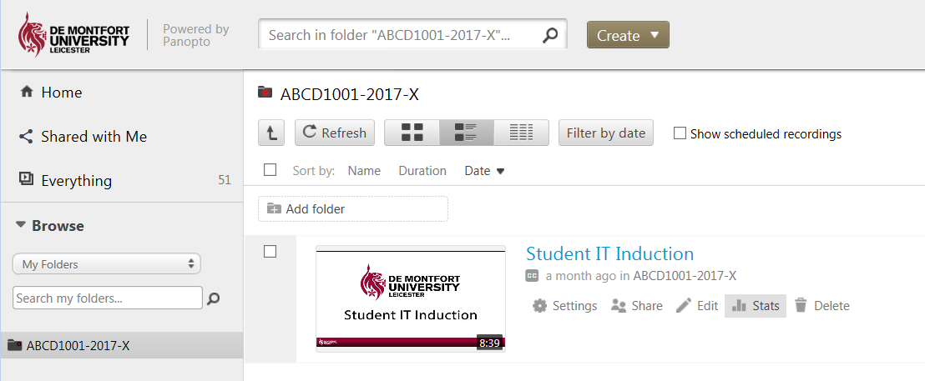
3. The viewing statistics for the recording will be displayed
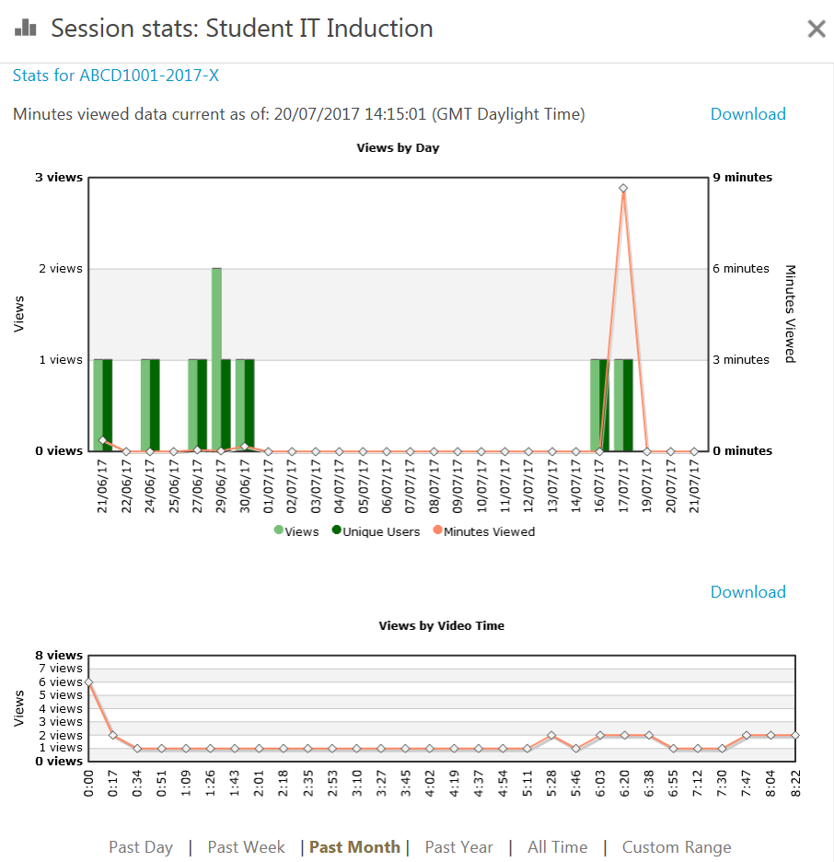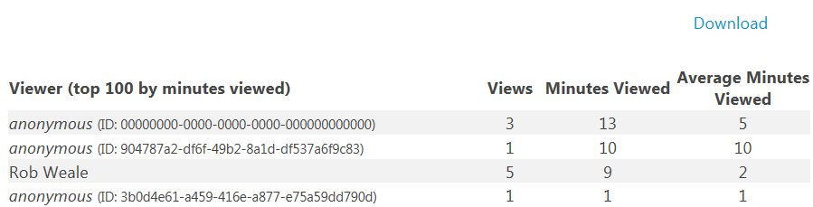
4. Stats can be downloaded and saved as excel spreadsheet data by clicking the Download link
