Accessing and Reviewing Assignments, Marks and Feedback – External Examiner
To locate submitted assignments
- Access Blackboard VLE using https://vle.dmu.ac.uk enter your user name and password. Select module Blackboard shell and go to Grade Centre tab in control panel
- Click on full Grade Centre
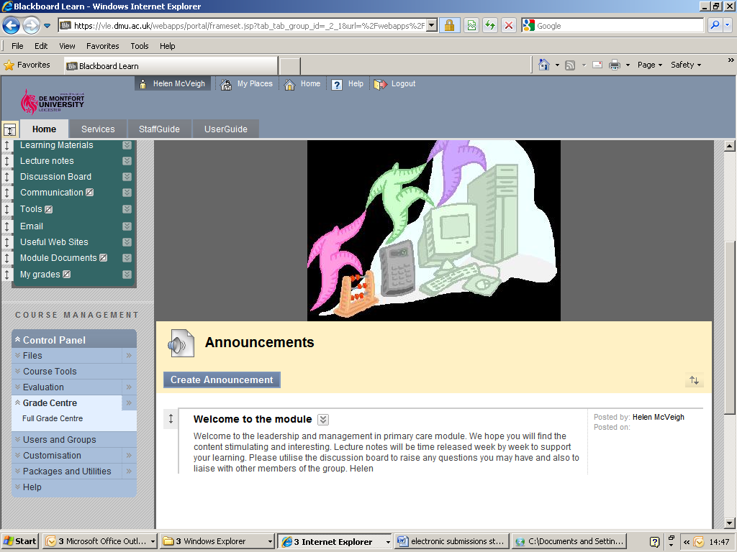
Click on Full Grade Centre
- Allow Grade Centre to load. All students enrolled on the course will be listed
- Scroll across to locate column for this assessment. 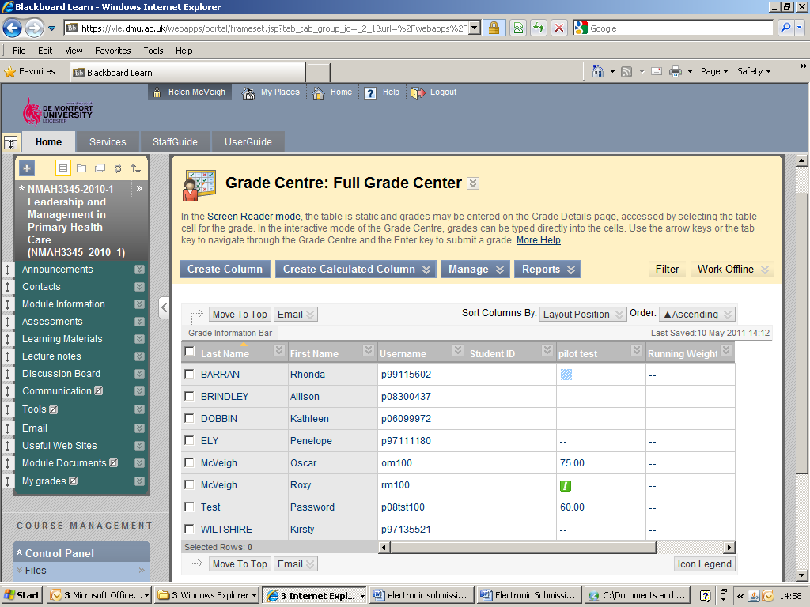
Awarded mark is visible
Scroll along this bar to locate correct column

- Hover mouse over grade and chevron appears on right hand side of this bar. Click on the chevron to access drop down menu and select Attempt Date 00/00/2011
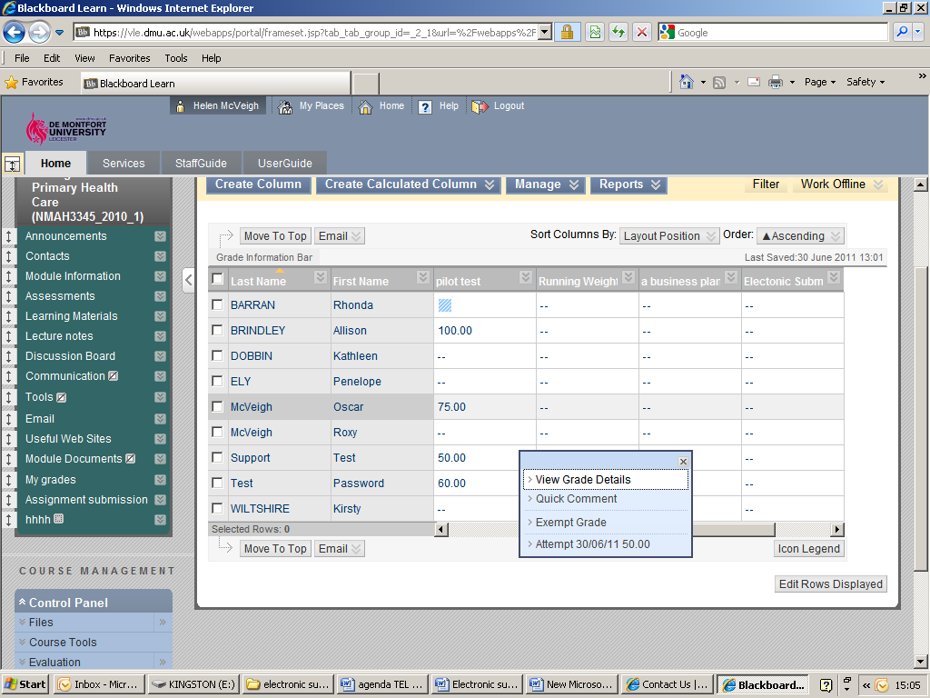
Select View grade details option from drop down menu.
- Grade Details window opens. Scroll down to review current attempt where submitted assignment is located.

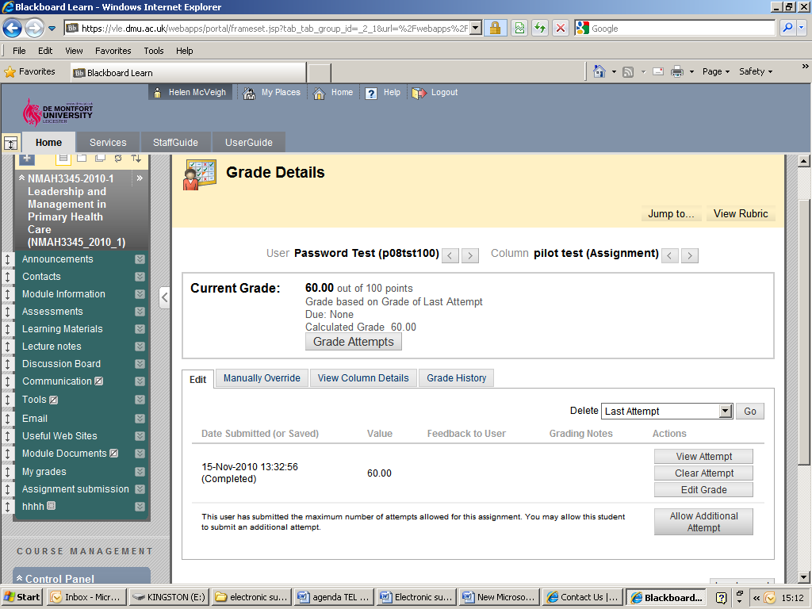
Select View Attempt

- Grade assignment page opens. Original submission is located under number 2 review current attempt, annotated version and feedback sheet is located under number 3 grade current attempt. Select which files you wish to view.
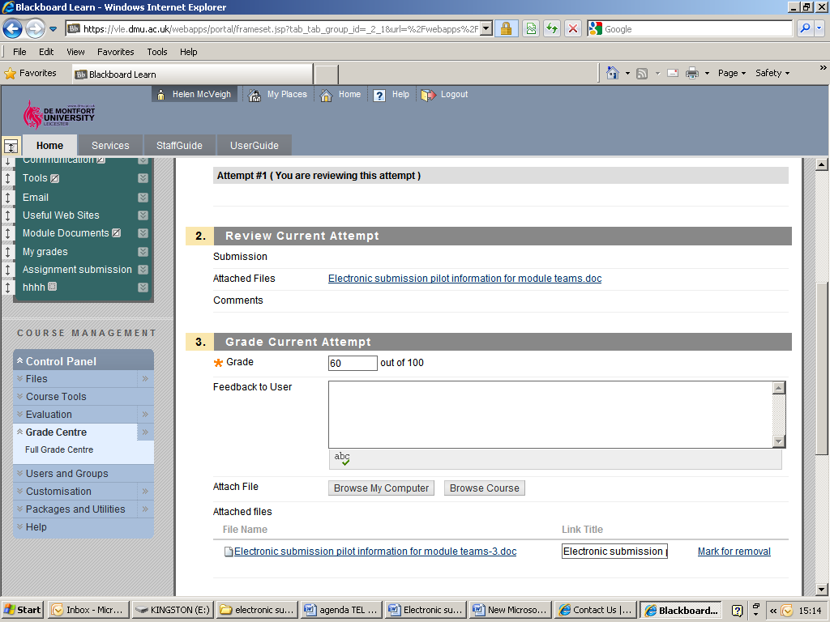
Original submission
file
Annotated file and feedback located here
Moderator comment
- You may now choose to either open the assignment and view or save to your desktop/file and then open.
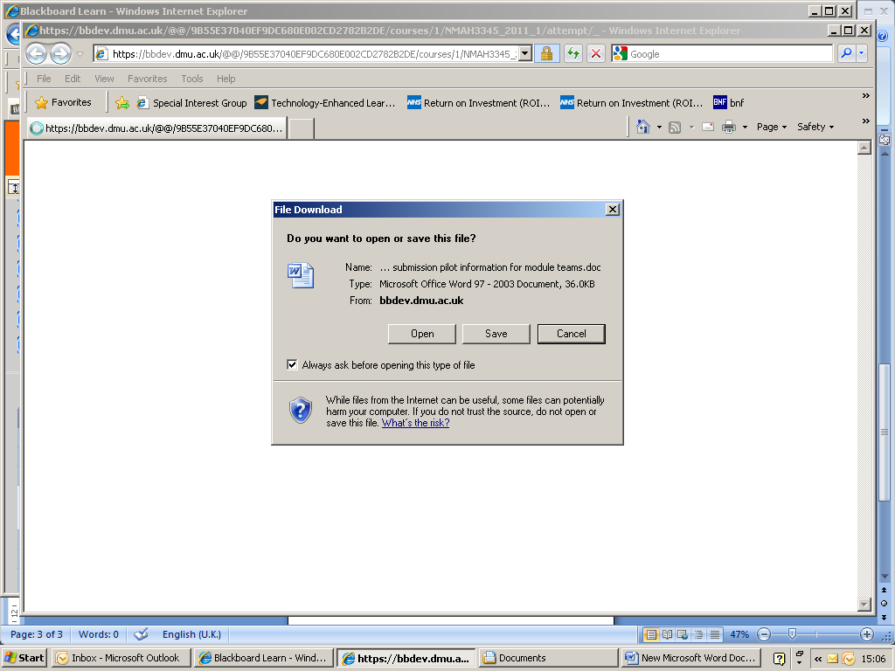
Select open or save to your desktop/file

- It is possible to download multiple assignments all at once. To do this instead of selecting the chevron next to the grade in 5 you should select the chevron at the top of the assignment column and click on assignment file download in the drop down menu.
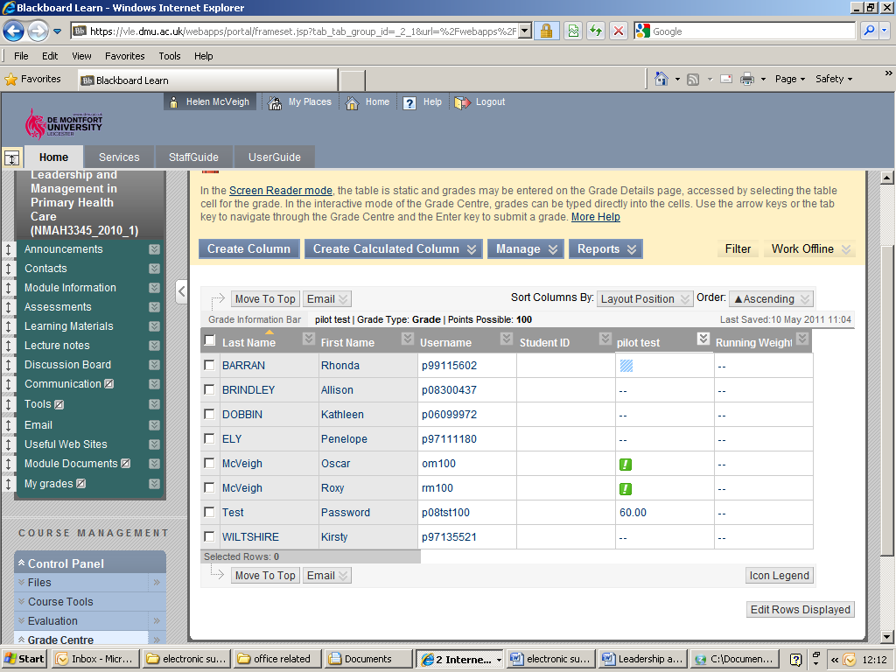
Select assignment file download from drop down menu

- Simply check the box next to the student names you wish to download and select submit.
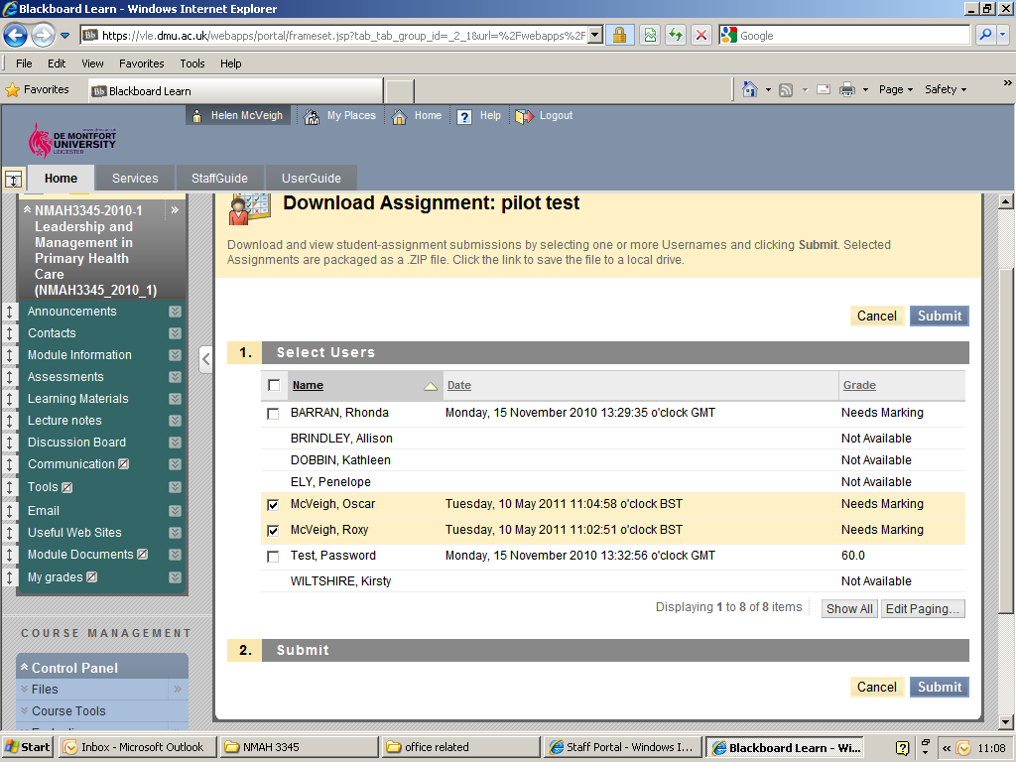
Select name of students you wish to view
- The assignments are presented in a zip file. Once you click on download assignments you will need to save the zip file and then extract the files to view them.
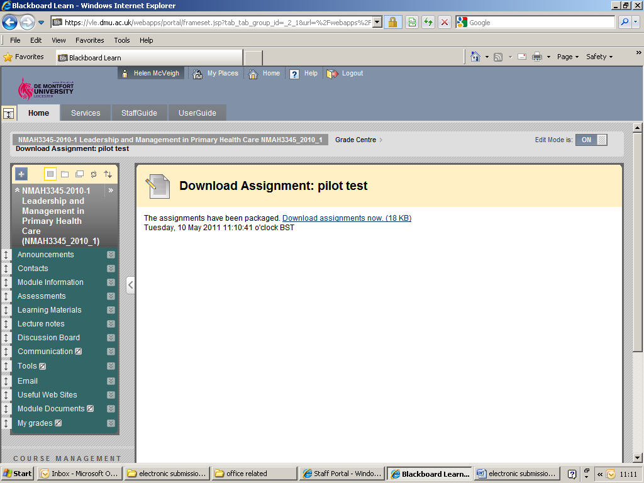
File will be downloaded as a zip file
- Return your feedback on marks/grades awarded to module leaders prior to STAB for ratification.

