Using the TurningPoint voting system
This short guidance document describes how to install and set up the TurningPoint voting system and create a basic multiple choice question slide. For more in-depth information please view the tutorials on the TurningPoint website.
What you will need
- A Windows PC with Microsoft PowerPoint installed.
- A set of TurningPoint handsets with dongle, available from A/V services.
- The Turning Point software is installed on all classroom computers
- It can be installed on your DMU desktop computer via Application Jukebox at: https://software.dmu.ac.uk/jukeboxdrm/showStreamit.do
  - If the above method fails to work – contact ITMS by phone at extension 6050
Once the software is installed, launch the software from Application Jukebox
When the TurningPoint dashboard opens – click on PowerPoint polling and PowerPoint will open.  Note: – when using the voting technology PowerPoint must only be opened using this icon – do not open PowerPoint directly or by clicking files in Windows explorer as the Turning Point functions will not work. | 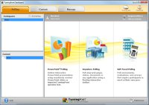
You will notice that you now have a new Tab in the PowerPoint Ribbon entitled TurningPoint.
Now remove the USB dongle from the case and plug it into an available USB port on the computer (the first time the dongle is plugged in, Windows will take a few minutes to install the drivers).
In the TurningPoint ribbon click on ‘New’ and select ‘Multiple Choice’ to insert a new voting slide. This can be added between existing slides in existing presentations to save starting again with presentations used in teaching. | 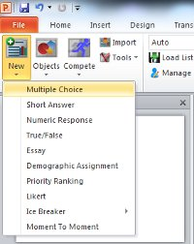
Using the placeholders, type the question and the multiple choice answers. It is good practice to anticipate the types of answer expected and cover off all bases with the options. Also, always include a ‘don’t know’ or ‘none of the above’ option.
As you insert more options, the slide will automatically update the graph – be aware that more than five options per question can start to cramp the slide.
It is always a good idea to test your slide(s) prior to the live environment. To do this, remove a number of the Turning Point handsets from the bag and ensure that the plastic tabs that isolate the batteries in transit have been removed.
Run your slideshow in the normal manner (press F5 or select an option from the Slide Show Tab). Your slides will display as normal but notice that when you get to the voting slide a small toolbar will appear at the top of the screen as shown below.
The green ‘Polling: Open’ notification indicates that the slide is ready to accept the audience members responses. This where you ask the audience to vote or in a test scenario randomly click to generate some dummy responses.
Note: – you must know exactly how many people are going to respond to the question. As the audience responds the ‘Responses:’ box will indicate how many votes have been counted – this tells you if anyone is yet to respond. If you fall short, get everyone to press again until you see that the number of responses matches the number of handsets that you have given out – TurningPoint will not double-count the votes that did register the first time around.
When satisfied that all responses are in, move on in the normal way. You will notice that instead of moving to the next slide the ‘Polling:’ box will turn red and display the word ‘Closed’ – the results output will now appear and show the results of the poll.
Move through the rest of the slides as normal, repeating the above for any subsequent voting slides.
Once the slide show is completed, click on the Save icon in the TurningPoint Tab.
Browse to the location where you wish to save the data, type a meaningful file name and click on ‘Save’.
Click on the Reset icon and reset the session to clear the data from the slides – the show is now blank and ready to be used again.
To view the saved data, navigate to the location where the data was saved as described above. You will see the TurningPoint icon with the file name that you created. Double click this icon.  TurningPoint will import the session data and ask if you wish to leave the data in its original place or move it. Select ‘Leave in Place’ before clicking ‘Ok’.  You will now see the Reports window. | 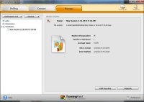
The dropdown menu should be used to select the type of report that you wish to see and/or export. For a basic view select ‘Results by Question’ and the view will update. | 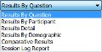
You may wish to export the data for further analysis – to do this click the ‘Export’ icon. Although there is an option to export to Excel it would be good practice, for compatibility reasons, to select ‘CSV’ as not only can Excel read this type of file, so too can other applications such as PASW Statistics and OpenOffice. | 