Visit CELT QuickGuides to get quick info about some of the most often used ELT approaches at DMU - http://celt.our.dmu.ac.uk/celt-quickguides/
Are you new to Blackboard at DMU? Have you used Blackboard before, but need a bit of a refresher?
Blackboard basics offers a comprehensive introduction to the use of Blackboard @ DMU. From logging in - to the initial setting up of a course - to creating teaching and learning content in Blackboard. Blackboard basics is all that - and more!

Contents:
About Blackboard - a general overview of Blackboard
Accessing Blackboard - how to login to Blackboard
The Blackboard home page explained - a tour of the Blackboard home page
The Blackboard Module/Course shell explained - a tour of the course/module shell, showing all of the tools that can be used to add and manage content on a Blackboard course/module shell
Designing your Blackboard Module - there are a number of things you need to consider when planning to deliver a module that has an eLearning/online component. The following guidelines have been geared towards using Blackboard, but many of the aspects are common whatever delivery media is being considered.
The Blackboard Course Creation Toolkit - all you need to know about setting up a Blackboard shell, enrolling people on it, and adding content to it - this section is a comprehensive guide on how to use all of the Blackboard tools to populate your course/module shell with teaching and learning content
The Blackboard Archive System - displays Blackboard courses from previous years. You can login with you usual Blackboard login details. Please do not add any live materials on this system

About Blackboard
Blackboard is our virtual learning environment which allows access to learning materials and interactive online activities. As a tutor you can have access to a course site which is automatically created for you to build (or upload) your learning course materials for your students.
Read more about how to set up and manage your Blackboard site
Blackboard has a number of features and tools which you as a tutor can enable and use in your teaching module; these include publishing your content; discussion boards, assignment submissions; sending students emails; collaborative working (blogs, wikis and setting up group work); tests and surveys and many more. Blackboard also has further advanced features which allow you to set criteria (date/time) when you want learning materials to be published as well as setting further conditions (met by criteria) when certain content is released.
The benefits of having an online course site are many and can include (to name a few):
- Staff and Students can access their learning materials outside of formal lecture times and off campus 24/7
- Create and manage your content and upload various file formats (including multimedia: audio, video) in a secure authenticated environment
- Customise and structure your module according to your teaching
- Date/Time release content items
- Staff can reuse their learning resources by copying them from one Blackboard module to another
- Supports communication through Discussion forums, Email and Course Announcements
- Integrated with TurnitinUK
- Set tracking and monitoring of students’ access
- Reduce the need for paperwork (e.g. lecture handouts)
- Create Group 'spaces' in a module to support group work
- Release content items to certain users
- Create blogs and wikis - collaborative learning tools
Find out more here in this pictorial overview
Return to top

Accessing Blackboard
1. Staff can access Blackboard through DMU Staff Portal
2. Students can access through their MyDMU website (my.dmu.ac.uk)
3. Blackboard can be accessed by staff and students by entering the following URL in your web browser: https://vle.dmu.ac.uk/
4. Blackboard can also be accessed through the Library Website
Logging in to Blackboard:
Staff login details: Staff Blackboard login details are the same credentials that you use for the DMU Single Sign in system (such as when you access the DMU Staff Portal site or Intranet).
Student login details: Their username is their Pnumber (on their student ID card), password is initially set as their date of birth in the format dd/mm/yy. However, students are prompted to change this password when they first login.
Return to top

Blackboard System requirements
The link below provides information about the minimum system requirements for effectively accessing Blackboard. All 'on campus' computers meet the minimum system requirement.
System Requirements
Return to top

The Blackboard Home Page
Main menu tabs
Once you log in to Blackboard, you will be able to see these following tabs on your Blackboard welcome screen:
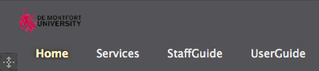
- Home – The Home tab contains information and access to the Blackboard Modules and Communities that you are enrolled on, and any announcements that have been made on any module that you’re are enrolled on.
- StaffGuide – the StaffGuide tab provides links to comprehensive Blackboard Help for staff
- UserGuide – the UserGuide tab provides Blackboard Help for students
- Services – the Services tab provides the user with useful links for example, DMU Library.
NOTE: Students will not have the StaffGuide tab available when they login to Blackboard

Blackboard Module/Course shell overview
When you enter a Blackboard course/module these are the key areas that you will use to navigate around the environment and to create/add content to your course/module
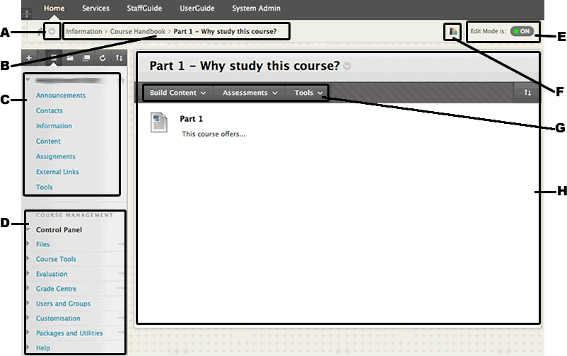
A - Course to Course navigation link
The Course to Course navigation link allows the site user to jump directly to a different Blackboard course. Clicking on the button opens a dropdown menu which lists the most recent courses visited and all of the modules/courses that the user is enrolled on. Clicking on a course title will take the user to that course.
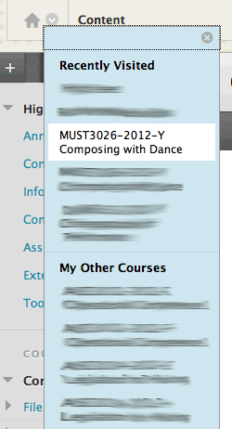
B - Breadcrumb Trail
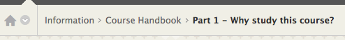
The breadcrumb trail shows the user exactly where they are in the course, and where they have come from. A user can use this to jump back to a previously visited area in the trail by clicking on one of the breadcrumb items (e.g. Course Handbook)
C - Course Menu
The course menu contains the main navigation links to content in the course - the course menu items (links) are normally referred to as Content Areas.
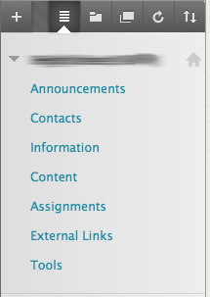
Tell me how to use the Course Menu
D - Course Management/Control Panel Menu
The Course Management/Control panel is only visible to Instructors on Blackboard and not students.
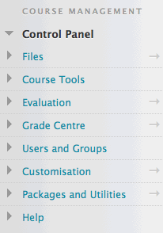
Each section in the Control Panel contains a dropdown menu listing all of the available tools in that section. The dropdown menu can be opened by clicking on the section title (e.g. Grade Centre). A specific tool within the section can be accessed by clicking its title in the menu (e.g. Needs Marking)
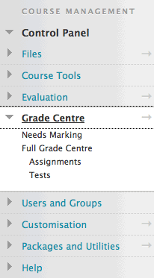
The following are links to information about how to use the various tools in the control panel:
Files
Course Tools
Evaluation
Grade Centre
Users
Groups
Customisation
Packages and Utilities
E - Edit Mode Toggle Switch
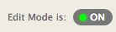
To add new content to a Content Area, or to edit existing content in a Content Area requires the Edit Mode toggle switch to be set to the ON position.
Clicking the button toggles it back and forth between ON and OFF.
When ON - instructors will be able to add and edit course content as you wish
When OFF - instructors will not be able to add, edit or change anything on the course.
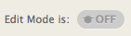
Setting the Edit Mode toggle switch to OFF is a good way to view your course as a student would see it.
(For obvious reasons, Students do not have the Edit Mode toggle switch available to them on their Blackboard pages
F - Style Template Selector
This tool allows you to change the appearance and style of your course environment (background colour/image, font colour and style, etc.). Clicking on the icon opens a dropdown menu from which you can select pre-defined course styles.
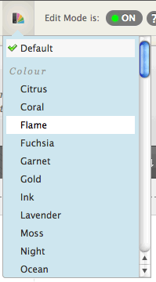
G - Create Content Tools
The tools available in all content areas are - Build Content, Assessments and Tools. Each of these 'content builders' have further options (when you drag your cursor over them) which allow you to build your content area.
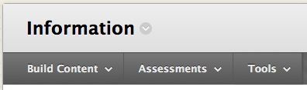
Build Content: Add files, links or other content such as documents, videos, audio, images
Assessments: Add tests, surveys and assignments
Tools: Add group and communication tools such as blogs, wikis, discussion boards, chat sessions
H - Content Area
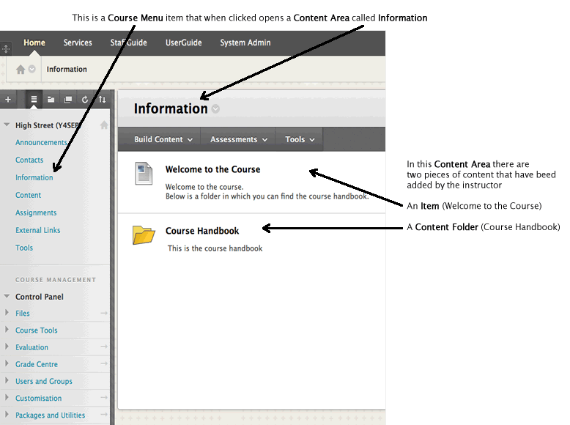
Return to top

Designing your Blackboard Module
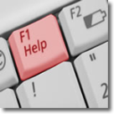 | Find out what Blackboard workshops are available for staff at DMU
Prior to beginning to design your Blackboard course, you must read the Blackboard Policy and we recommend you read the DMU Threshold for the use of Technologies in the Curriculum
There are a number of things you need to consider when planning to deliver a module that has an eLearning/online component. The following guidelines have been geared towards using Blackboard, but many of the aspects are common whatever delivery media is being considered. We have, however, included them all to provide a reasonably comprehensive guide, which we hope is useful to all staff whatever their prior experience and expertise. When considering designing your online module it is essential to understand the tools and features available to you so that you can make an informed choice of what you can use and is suitable to support your teaching and delivery in the online environment.
Section 1: Instructional Design
Covers the basics of instructional design and contains some prompts for you and your module teaching team to consider
Section 2: Getting your Module Online
Covers the mechanics of applying this instructional design thinking to Blackboard

Section 1: Instructional Design
Thinking through the following issues will help you to plan your module effectively.
What information do you want to use to describe the module?
Describe the purpose of the module and what the module is to cover, as well as its learning and assessment strategy. Let your students know why they should use the site, to show how it fits in with the broader delivery of your module. Either create a “Read this first” button, or post a welcome Announcement to explain the purpose of the site. Do not make the assumption that students will know what to do, outline some guidance from the onset if possible.
Course Structure
Think about the learning journey of those who will be using your online site and how this complements any face to face teaching that you do. Is your site easy to navigate with a clear course menu so that students can find what they are looking for? Have clear meaningful labels for you course menu, folder structure and any items you upload. Some useful tips in the article below - Some Simple Steps to enhance your Blackboard Site - from the E-learning newsletter 2005 are still relevant today:
Download - Some Simple Steps to enhance your Blackboard Site [PDF]
What supporting documents will you use?
Module handouts, lecture notes, or other visual aids may be used to guide students through the module. How will these be created? You can use existing file formats to upload your learning materials. Will some collaboration tools be more apt for engaging students, for example blogs or wikis?
Are there assignments that students are to complete?
Are there assignments that students are to complete? If so what are they and when should they be available? Blackboard allows you to time/date release some learning materials and you can also set contents in a content area to have conditions based on criteria set.
Are there Web sites or other external links?
You can use the External Links page to organise content and external links for students to view.
Do you want to use the discussion board?
The Discussion Board is useful for posting information for all students to view. The discussion board is also useful in facilitating ongoing discussions about various topics. Are there topics that could be facilitated by a discussion board? If so what are they?
Do you want to use the virtual classroom option?
Perhaps you want students to have the ability to go on-line at the same time to discuss a topic or you wish to have online office hours. The Virtual Classroom tool (Collaborate) in Blackboard may be useful.
What type of assessments do you want students to complete online?
Quizzes and tests are just a few assessments that can be completed and graded on-line.
Do you want students to complete a survey of the module?
Surveys can be used to give students the opportunity to offer feedback about what worked well in a module and what may need improving. Do you want students to complete a survey of the module? If so what feedback would you like?
Do you want to organize students into groups?
Students can be organised into smaller project or study groups. The instructor has the option of giving the group - discussion board functions, virtual classroom functions, group file exchange functions, and group email functions. Do you want to organise students into groups?
You should also think about the following questions when planning and implementing your site.
- Who will manage your day-to-day use of Blackboard?
- Which team members need access?
- What will be the structure of your Blackboard site?
- How does this structure mirror your day-to-day processes?
- What content areas do you need?
- What Blackboard tools, like the discussion board, do you need to use?
- What content do you need to share?
- Who will build this content?
The following checklist may be useful to module teams when developing materials within Blackboard
Criteria | Yes/No
The Blackboard materials have been discussed and planned with the relevant module or module team.
The materials map onto relevant learning outcomes.
The Blackboard supported elements of the module explicitly align with the other module learning and teaching strategies.
The Blackboard supported elements of the module explicitly map onto its assessment strategy.
The materials support a variety of learning styles.
The content has been developed in accordance with Universal Design for Learning principles
The content satisfies the requirement of the DMU Replay policy
The structure of the Blackboard module is deemed appropriate by the relevant team.
Content for the Blackboard module is deemed appropriate by the relevant team.
The Blackboard supported elements of the module are suitable for a range of student IT expertise.
Appropriate student induction, training and support are planned.
Equality of access to materials for all learners has been planned, for both contact and non-contact opportunities.
It is important that you think about the questions in the previous section in light of the events that prompt the necessary conditions for learning to occur. These instructional events can help you determine the most effective ways for your students to structure their learning.
The following is based upon Robert Gagne’s work.
1. Gain Attention The purpose of this event is simply to arouse your student’s curiosity. You might ask leading questions, create scenarios, run on-line demonstrations, or point to external Web sites that promote curiosity and exploratory learning.
2. Inform the learner of the learning outcomes Learning outcomes are the pivot for the scope and meaning of the module and should be discussed with the students from the start, in light of your module learning, teaching and assessment strategy.
3. Stimulate the recall of prior knowledge “Scaffolding” or building upon prior knowledge and experience is a crucial teaching method. You may begin the module with some review of prior materials, create self-assessment tests covering materials from required pre-requisite materials, establish parallels to common knowledge, and/or provide hypertext links to basic background materials. You can then make links to new materials.
4. Present effective learning materials Provide students with the materials to be learned or the means by which they can actively discover them. You can create short audio/video lectures, PowerPoint presentations, text examples, links to the Web, projects, and experiments that ask students to search out materials and then present these materials to the class.
5. Provide Learning Guidance Rather than “telling” students everything they need to know via a lecture or discussion, consider creating opportunities for self-learning or group collaborative learning through discussion questions, listings of resources for study and exploration, and the creation of small, progressive assignments that allow for ongoing evaluation and assistance in individual student understanding. Given the autonomous nature of the online environment and the added demands in managing an online class, providing opportunities for student-led learning can be especially important.
6. Provide Feedback Prompt and consistent feedback is essential in any environment, whether it consists of threaded discussion responses, email comments on papers and assignments, or seminar work. Feedback can be both individual and general to the group.
7. Assess Performance In this event you must decide whether the “performance” truly indicates that real learning has occurred. Assessing performance can include exams, projects, papers, threaded discussion messages, or laboratory or field experiments performed at a distance
8. Enhance Retention and Progression Ask students to apply their newly acquired knowledge to other learning situations. Create module-long projects that are culminations of overall learning in the module, or require end-of-module portfolios that show progress in the module through items such as essays, discussion board interaction and self-evaluation.
Return to top

Section 2: Getting your Module Online
Steps 1 to 6 are what needs to be done before working on populating/building your Blackboard course site.
Step 7 onwards assumes that you have some knowledge of how to populate a Blackboard course site and are able to start work on this.
1. Prepare yourself
Preparation is worth all the time that is spent on it, as it can save time in the long run; but it does require an initial, upfront commitment of time. Discuss your ideas with your colleagues who teach other modules, or units of your module to your students – this helps you and them to sort out ideas and keep up to date with developments of other modules and units which should affect what you decide to do with yours. Attend Blackboard workshops at DMU; talk to your Faculty ELT Project Officer; look at other Blackboard sites; explore the software. You don't have to use all the features of a web-based on-line learning environment to begin with – it depends on how much time you have, how confident you are with certain features such as on-line formative assessment, wikis, etc.. You can build in more features next session. If your site is a passive one in the first year, the requirement being to front load students with key knowledge/information, you may well need to make it more interactive in subsequent years and provide spaces in which the students are freer to explore information and knowledge sources in a more independent mode of study.
2. The student perspective Try and put yourself in the position of a student:
- will they be very confident in their use of IT?
- will they have used an online learning environment before?
- will they have done electronic submission of essays and/or used Turnitin?
- will they have used a blog or a wiki or taken part in an online discussion?
3. Build a module skeleton
Create the organisational structure for your module – create a set of clearly labelled folders to hold module materials; plan a folder for every element of your outline including the assessment strategies and other items of module management. If you haven't created a structure of this kind before we suggest you have to hand plenty of sheets of paper on which you can create a template for your module structure.
4. Make an outline
Match module components with dates and materials – this is crucial. Are you having formative assessment? If so, when? If not, why not? Make the outline in collaboration with colleagues who also teach your students – this is very important.
5. Prepare your materials
- Gather the materials you need: handouts, slides, assessments, lecture notes
- Get an idea of how much exists in digital format
- If the development is as part of a team, work on your materials, learning outcomes and assessment criteria collaboratively
- Book some consultancy time with your Faculty ELT Project Officer. Plan to create folders that correspond with the main topics or sections of your module, and plan sub-folders as necessary (for instance, Week 1, Week 2 etc.).
6. An interesting site
Why should students keep visiting the site? New and interesting things posted regularly alongside integration of the site into the Learning, Teaching and Assessment process will engage your learners. If you don’t bother, why should they?
7. How are you going to deliver the materials?
What is online and what isn’t? Decide whether you are going to use the Web to communicate with your students, or whether some part (or all of it) is actually going to involve learning on the Web. You might decide to supplement tutorials with online sessions; you might decide to offer the students formative assessment opportunities, delivered via Blackboard, that do not count towards the final mark.
- Get the on-line material/information into digital format
- Check the copyright situation at an early stage
- Throw some material out, don’t fall into the trap of “filling up” your web site with irrelevant content. Merely putting notes online is of limited value.
8. Create a Blackboard Module Site [tell me how?]
9. Add content/information
Start putting the content/information in the appropriate folders; include a short description for each item, saying what it is and what relevance it has – spell it out for the students.
10. Add staff information
Get some information in about yourself, and anyone else associated with the module. You may want to add photos of the teaching staff members (this is not mandatory).
11. Incorporate the technology with other module components
Post an introductory assignment – do it as a sort of digital icebreaker, ask them why they picked this unit, make it a requirement that they read each other’s efforts (maybe not all of them). Creating an on-line community, such as a discussion board or wiki can often work very well. But be sure to make absolutely clear to students at the outset what your commitments as a tutor are regarding eLearning - such as the extent to which you will be participating in these online communities. Don't raise expectations that cannot be met. We need to use the technology to enhance communication but this does not mean increasing the tutor work load. Seek advice if you are new to this sort of thing. You might plan on adding one new topic to the discussion board on a regular basis – think it through, make sure it has legs, encourage students to follow up threads. Have some good quality external links already set up, get the students to find, evaluate and share sites by posting the appropriate details.
12. Create an introductory announcement
Post a welcome message, direct them to the areas they need to visit first such as the module outline, direct them to the location of the first assignment. Navigation to materials should be 'intuitive'.
13. Final test
View the course site from a student's perspective – what use is it? Why should I revisit the site? and how often? Check that all of your links to external websites/material are working, you may want to ask a colleague to 'proof view' the course site.
14. Implementation
Plan the implementation and introduction to students. Where will this be done? Will you need help? Is this the first time your students will have used Blackboard? Do you need to be in a computer room? Give students the URL and sort out their logins and passwords. Make the use of the site integral to the unit/module – if its use is purely optional few students will engage with it.
15. Review, evaluate and revise
You may want to include an online survey in your Blackboard course site for students to complete, whereby they offer feedback on the course site.
16. Back up your work
At the very least, you should have a printout of key pages so you know what is there. We recommend that you maintain a mirror (duplicate) file and folder structure of your site on your computer hard-drive or network storage space.

